**DATASET -1**

**Loan Application Status Prediction**

Loan application status prediction is for banks or financial organisation who lent the loan to people on various basis. Banks or financial organisation have large number of loan applicants and it’s been very difficult for them deciding which applicant is capable of repaying the loan and who can be defaulter. In this dataset we have loan applicants with their various info about them and we have to build a model predicting the applicant can be defaulter or not.

**Problem Definition:**

Loan application status prediction dataset includes details of applicants who have applied for loan. As it depends on numerous factors on which the applicant is married, employment status, the amount of loan applicant is applying for, previous credit history, property belonging to applicant etc. Such cases are often classification problems.

This dataset includes details like:

**(Independent variable)**

- Loan ID

- Gender

- Married

- Dependents

- Education

- Self Employed

- Applicant Income

- Co-applicant Income

- Loan Amount

- Loan Amount Term

- Credit History

- Property Area

**(Target Variable)**

-Loan Status

**Data Analysing**

Initially we will call import all the libraries required to run this dataset.

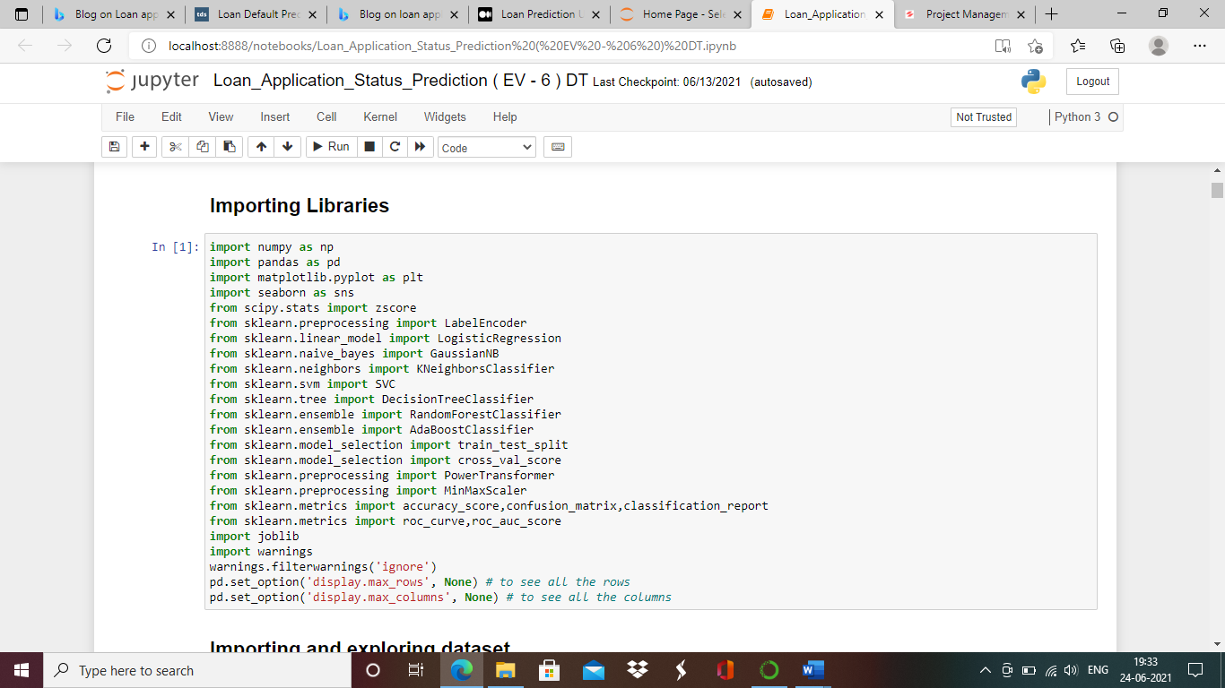

Now we call the data set for analysing .

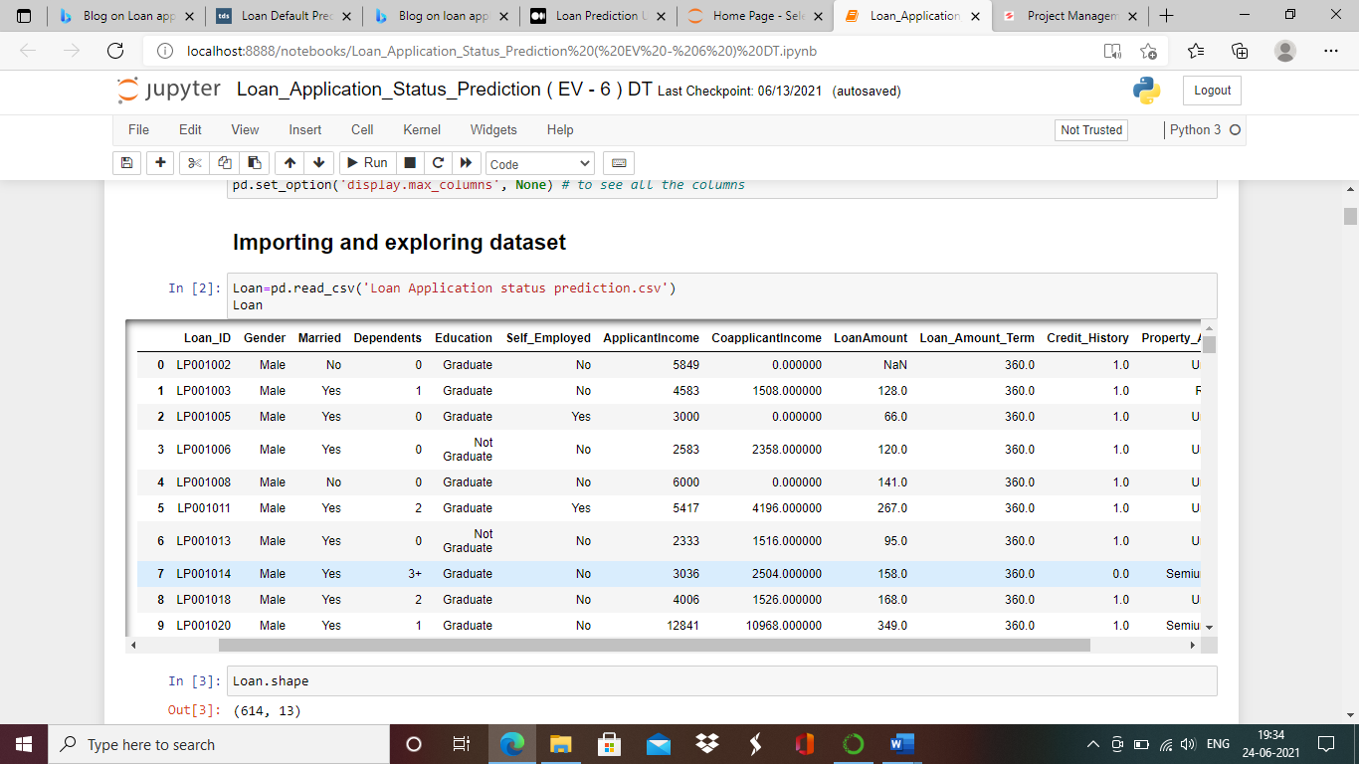

We will call this dataset as Loan for futher operation ,lets check the number of columns and rows in this dataset.

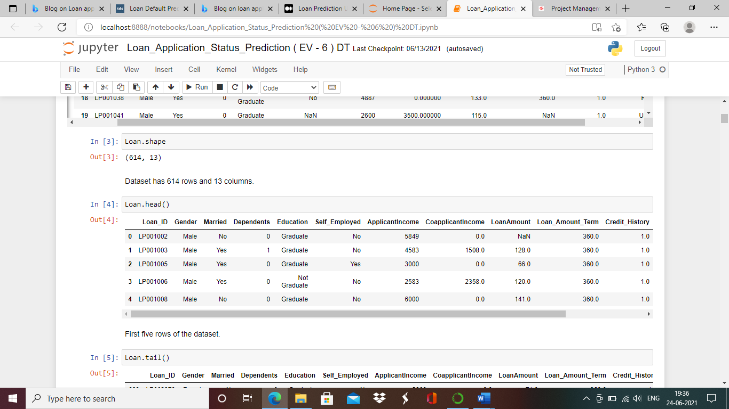

There are 614 rows and 13 columns in loan dataset ,means there are 614 applicants.

We will check the data type of the columns .

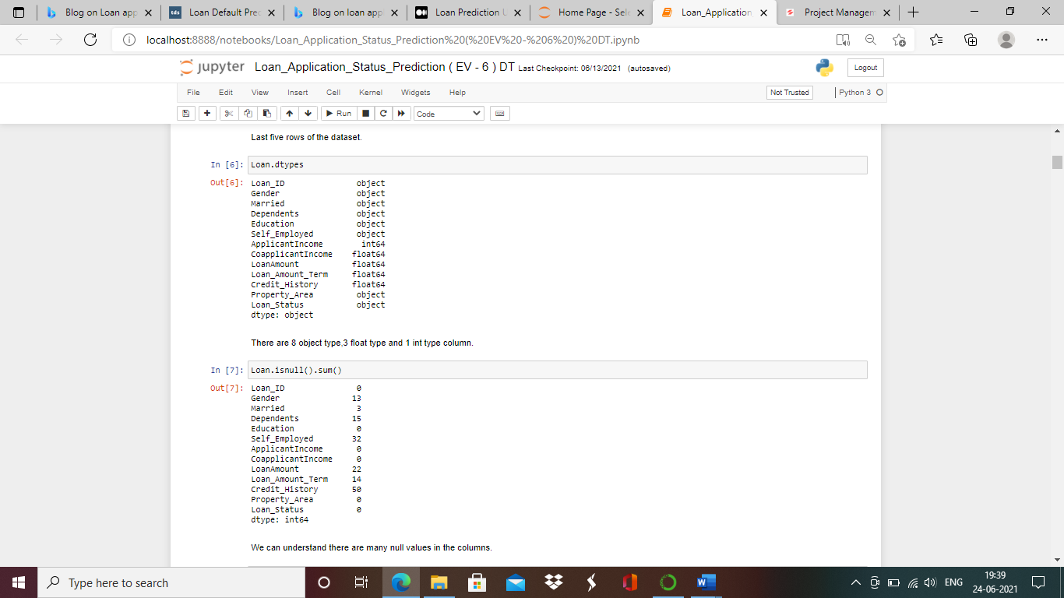

Most of the columns in dataset are categorized and object type. Coaplicant income,Loan Amount,Loan Amount term,Credit history are in float and only Applicant income is integer type.

Check if Null values are present in dataset.



Looking at categorised column there are 13 null vlaues in Gender column,3 null values in married column,15 in dependents column,32 in self employed column,14 in loan amount term and 50 in credit history column.

In continours variable columns we can see null values only in Loan amount column.

**Check Unique variables in categorised columns.**

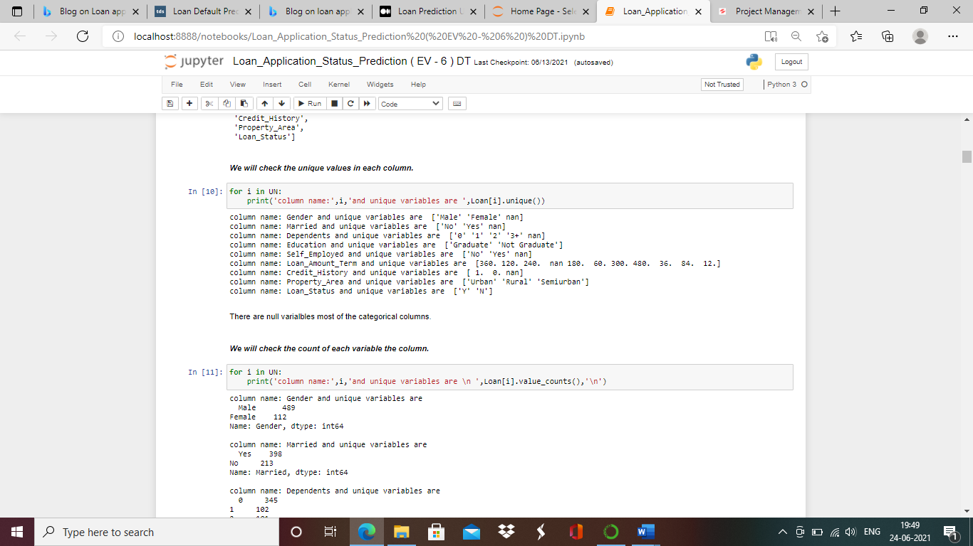

We can understand from above the unique variables in column,columns like property area defines whether the applicants property is in rural,urban or semiurban are.Self employed states whether applicant is doing service or is self employed.Credit history makes us understand whether applicant has an credit history in past ( 1: Yes and 0: No ).

**Lets get statistical understanding of Loan dataset for numerical columns**

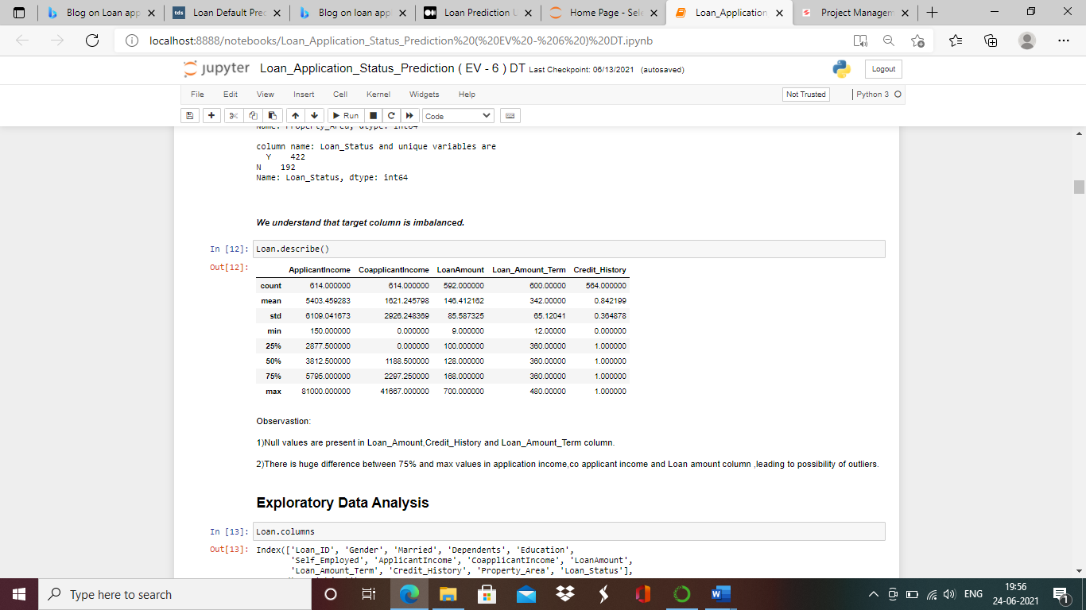

Observations:

1)Null values are present in Loan Amount, Credit History and Loan Amount Term column.

2)There is huge difference between 75% and max values in application income, co applicant income and Loan amount column, leading to possibility of outliers

**Exploratory Data Analysis**

**Univariate Analysis**

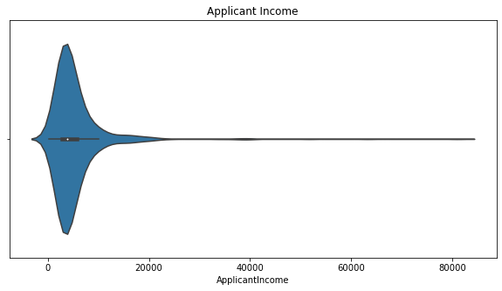

Observation:

There are more people with applicant income o to 10000

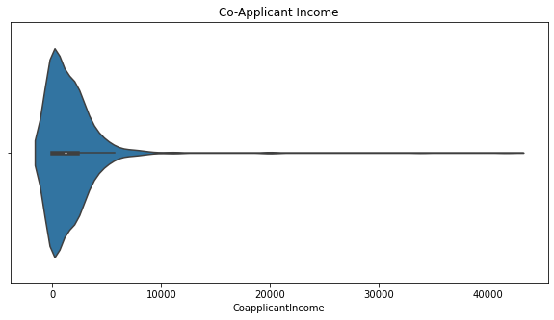

Observation:

Co-applicant income ranges majorily in range of 0 to 5000.

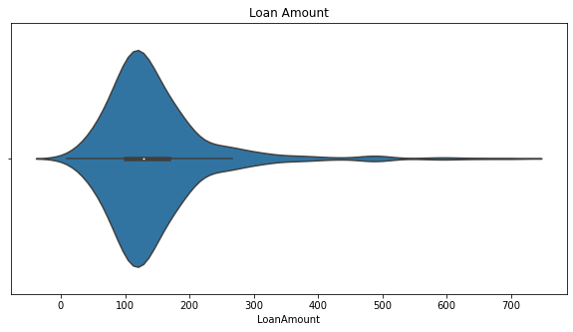

Observation:

Majority of people are looking loan from 50 to 200.

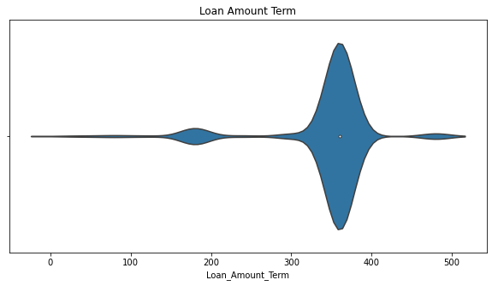

Observation:

1)Loan amount term is majorly from 300 to 400.

2)Few people are also applying loan amount term from 150 to 200.

3)Very few applicant are also looking for loan amount term from 450 to 500.

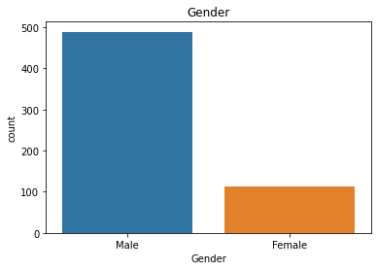

Observation:

Male candidates are more than females for loan application

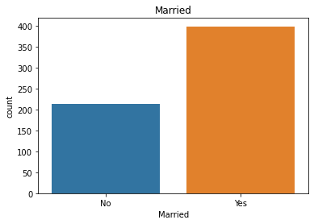

Observstion:

Married candidates are more compared to unmarried for loan application

.

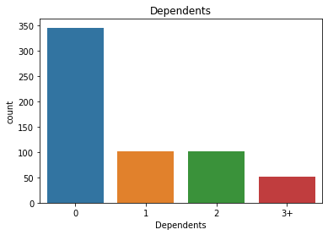

Observastion:

1)Almost 350 applicant have no dependents.

2)Applicant with 1 and 2 dependents are almost same around 100.

3)Few applicant have 3+ dependents.

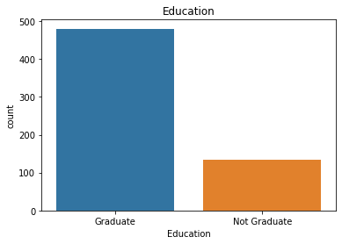

Observation:

1)Close to 500 applicants are graduate and very few approx:120 are not graduate.

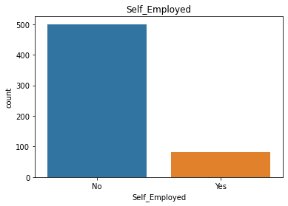

Observation:

1)Around 500 applicants aren't self-employed reaming approx. 100 applicants are self-employed.

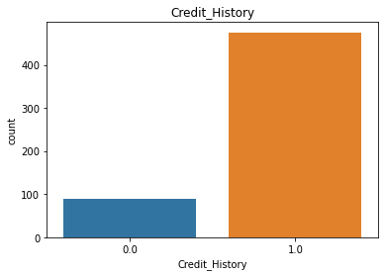

Observation:

1)Applicants with credit atleast once are in majority of numbers.

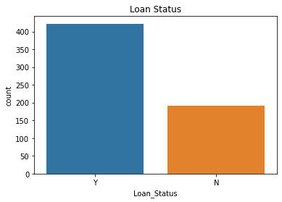

Observation:

1)Loan application for most of the applicant has been approved and few have been rejected.

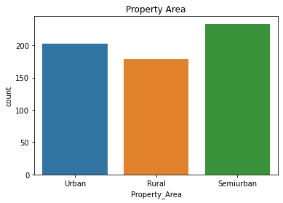

Observation:

1)Most applicants have property in semiurban area, approx. (200) applicants have property in urban.

**Bivariate Analysis**

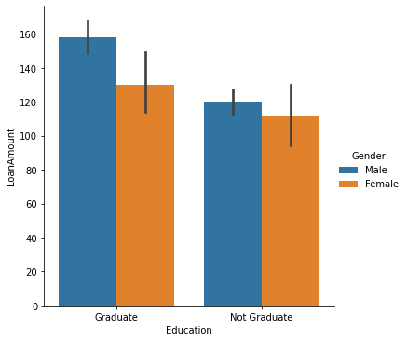

Observation:

1)In application of higher loan amount, male applicants are more in both graduate and non-graduate list.

2)Female applicants apply for lesser loan amount compared to male applicants, irrespective of qualification.

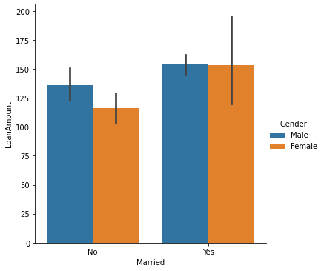

Observation:

1)Married applicants apply for higher loan amount compared to unmarried.

2)In Unmarried category male applicant apply for higher loan amount.

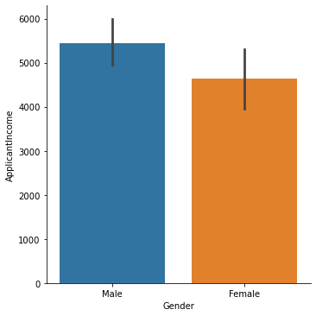

Observation:

1)Male applicants income is higher than female applicant.

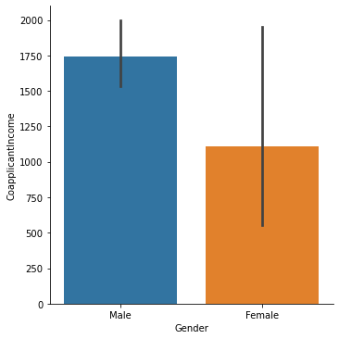

Observation:

In co-applicant’s male have higher income than females.

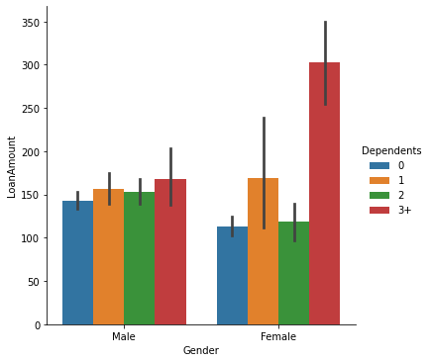

Observation:

1)Females and makes with 3+ dependents have applied for higher loan amount.

2)Males and females with 1 or 2 dependents have applied for almost similar loan amount.

3)Males with no dependents have applied for more loan amount compared to females with no dependents.

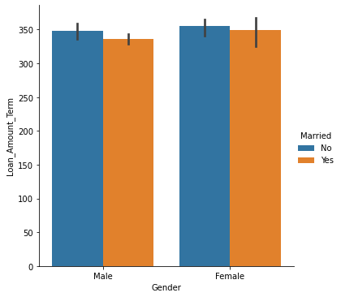

Observation:

Loan amount term is almost similar in males and females. Unmarried males tend for bit higher loan amount term.

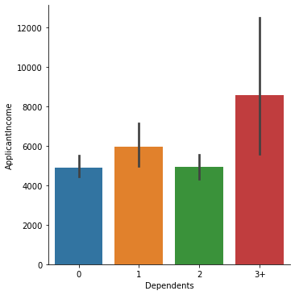

Observation:

Applicant with 3+ dependents have highest income.

Applicant with 0 or 2 dependents have similar income.

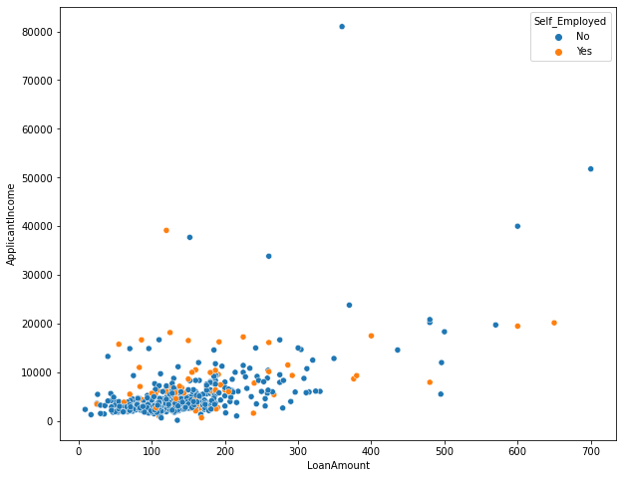

Observation:

Loan amount and applicant is positively correlated and not self-employed applicants are more

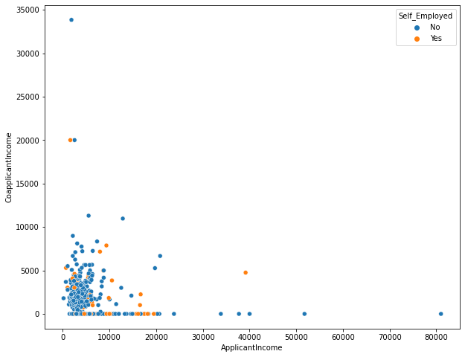

Applicant income and co-applicant income are positively correlated.

There are more non-self-employed applicants

**Multivariate Analysis**

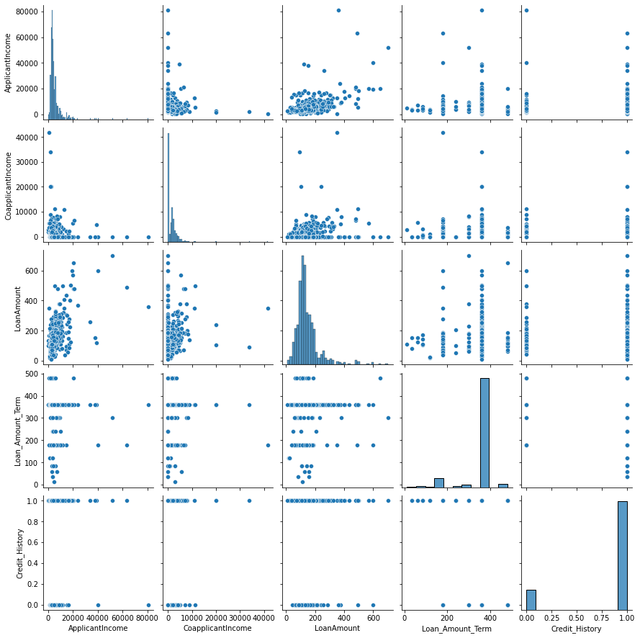

**Pre-Processing Pipeline**

EDA process has helped us to understand the data much better. Now, let’s treat the missing values in dataset.

Earlier we had checked the unique variables in categorized columns, now lets check the count of these variables

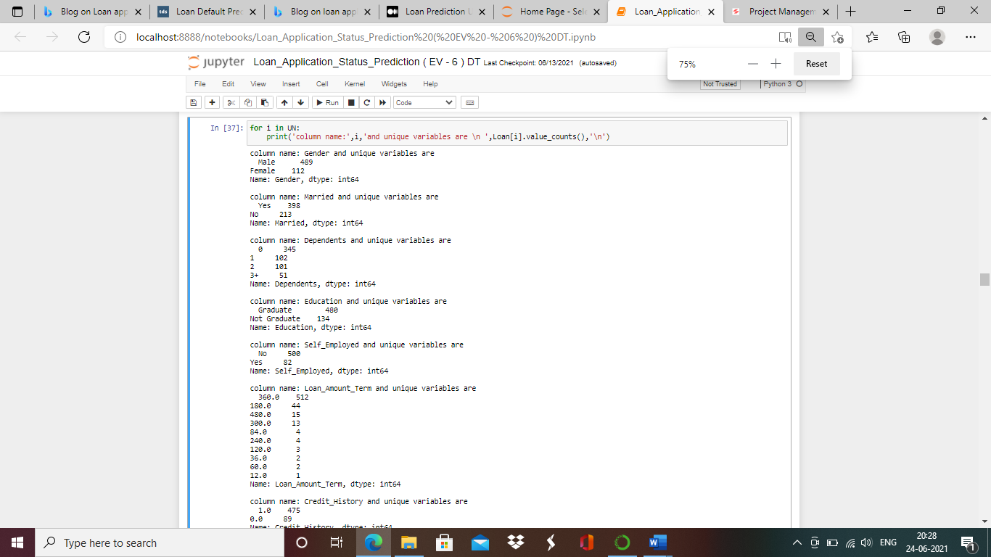

Above we can understand the count of unique variables in Gender,Married,Dependents,Education,Self Employed and Laon Amount Term columns.

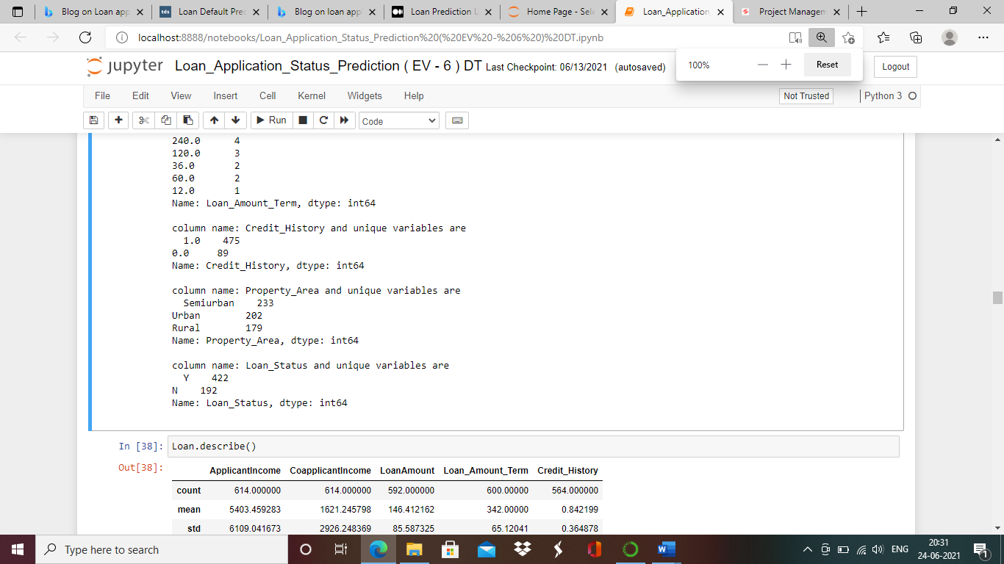

Loan status is our target/label column and can understand target column is imbalanced.We will correct the imbalancing later.

Treating Missing Values of Loan Amount:

We will check dist plot to confirm whether to fill missing values with median or mean value.

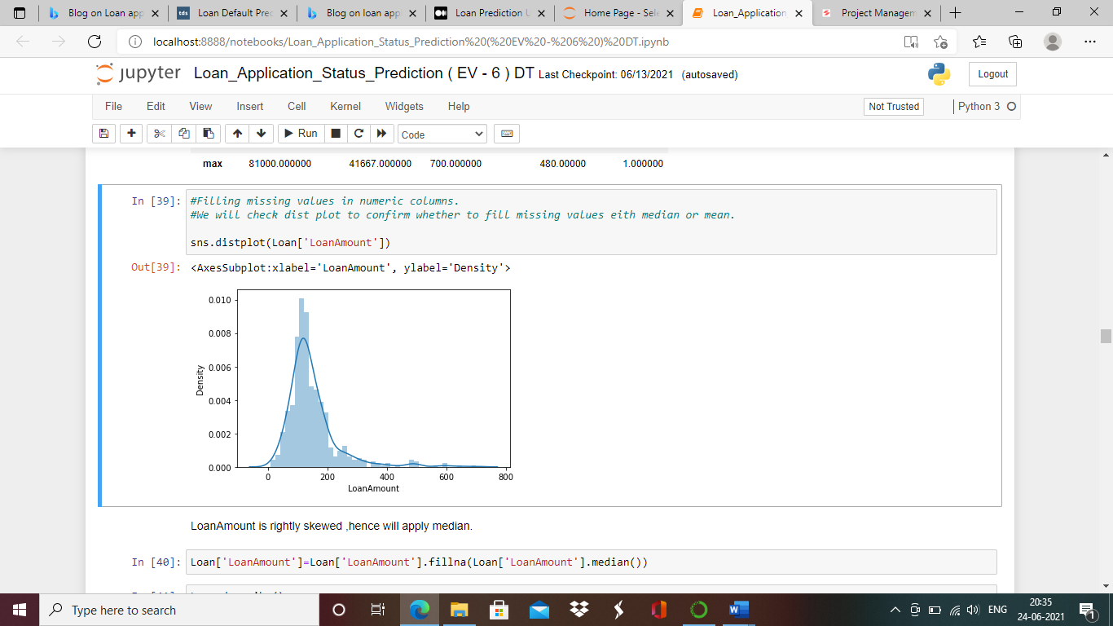

Loan Amount is rightly skewed ,hence will apply median.

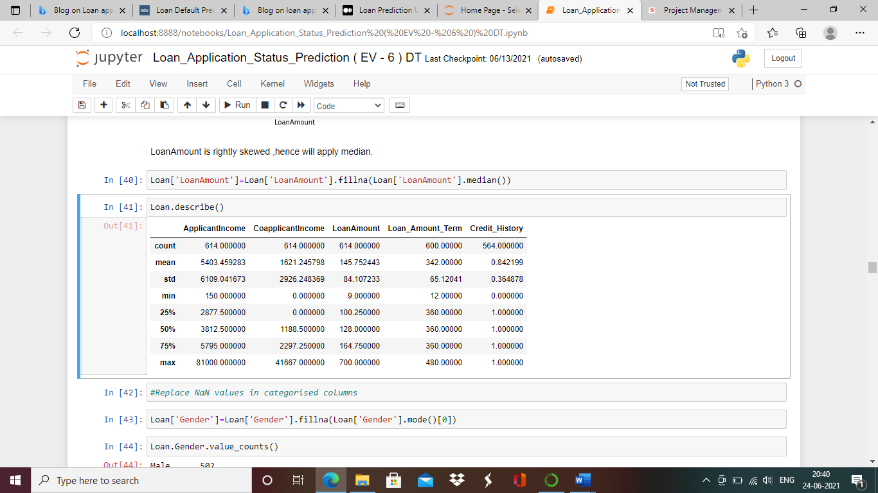

Treating Missing Values of Gender ,Married , Dependents, Self Employed, Loan Amount Term, Credit History:

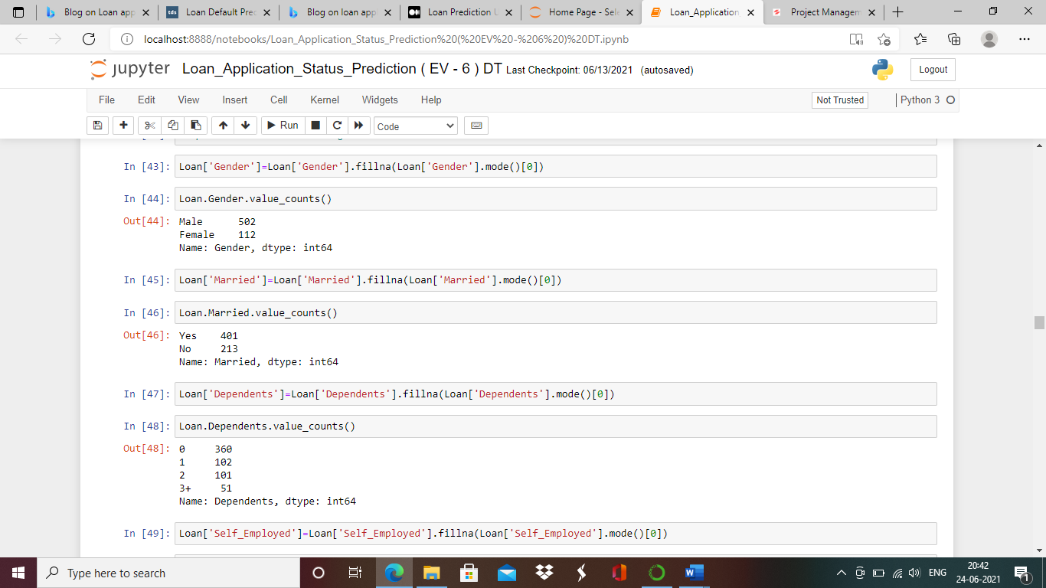

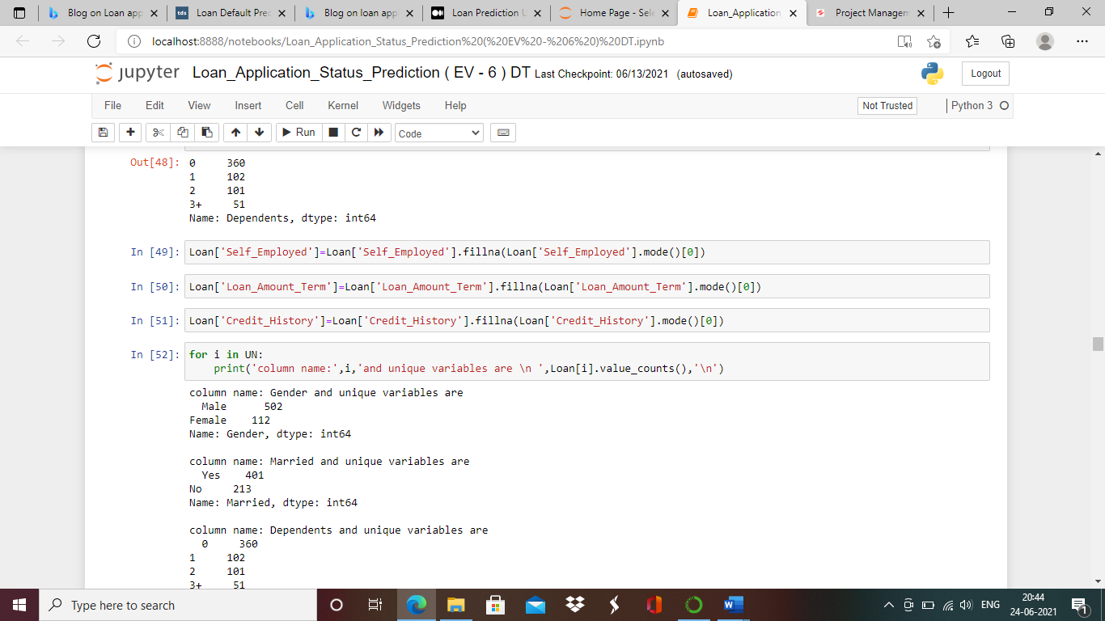

We will drop the column Loan_ID as it is unique identity number given to customer and won't help in model performance to determine loan approval***.***

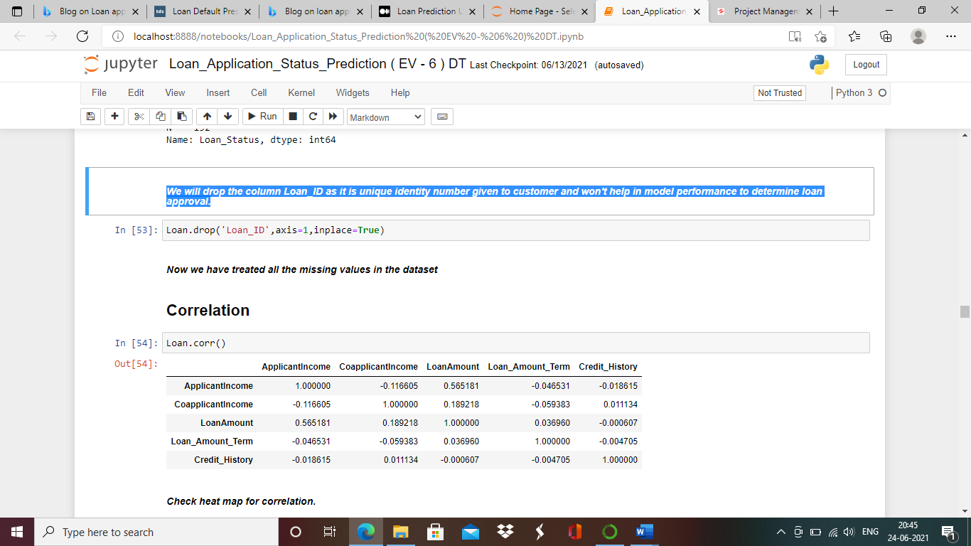

We have now treated all the missing values from loan dataset.

**We will check correlation of the columns**

Below is table justifiying the correlation of the columns.

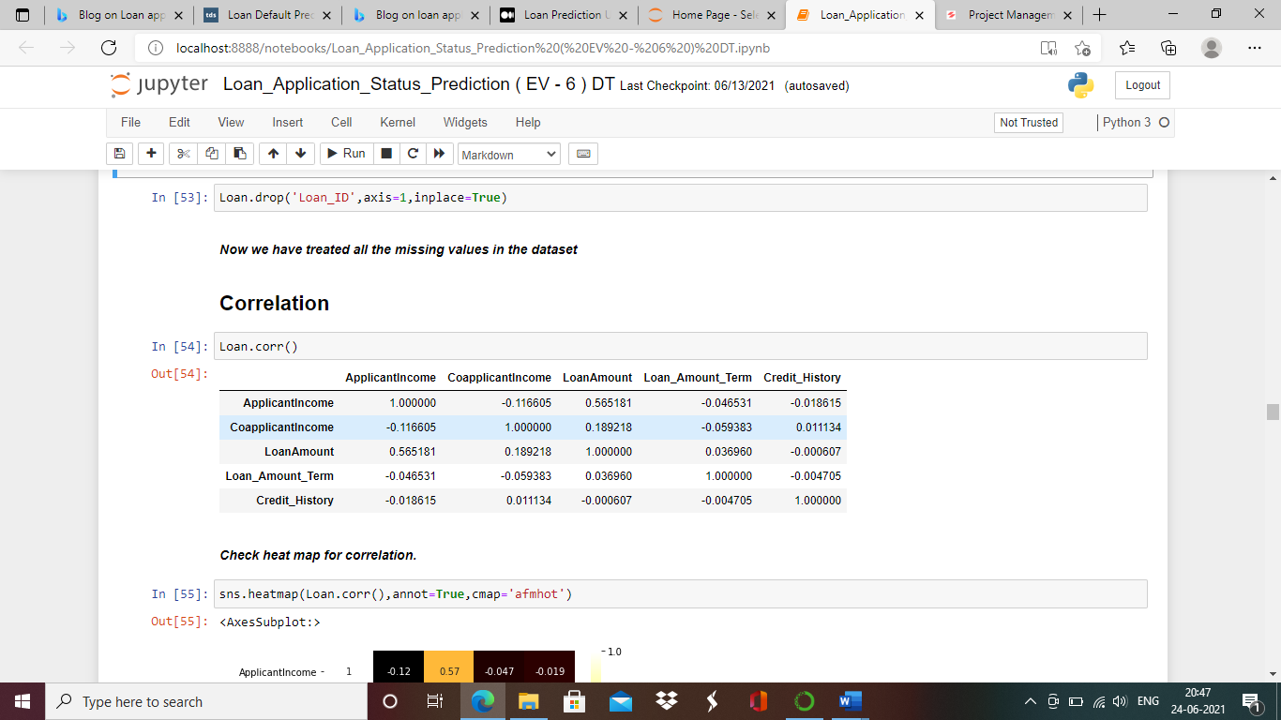

For better understanding of the correlation between columns we will plot the correlation with help of heatmap.

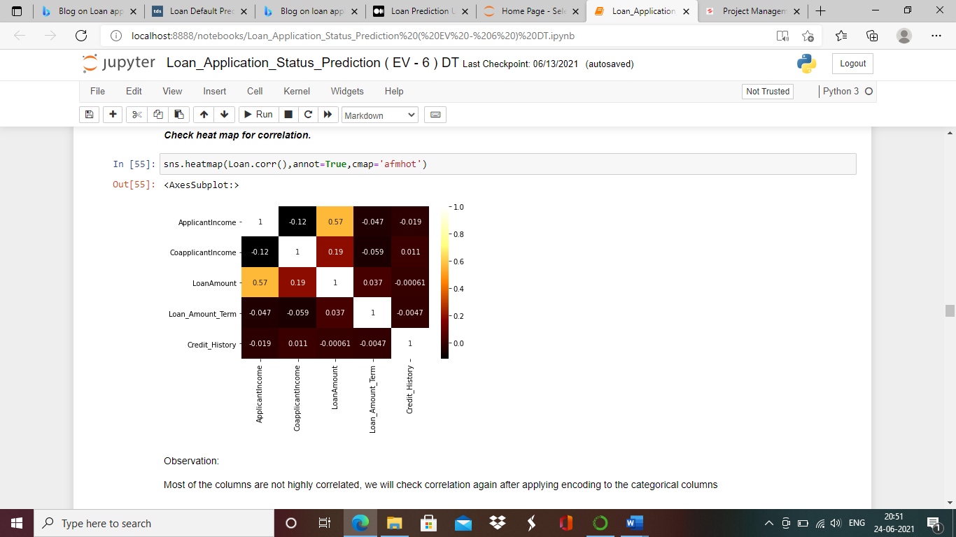

Observation:

Most of the columns are not highly correlated, we will check correlation again after applying encoding to the categorical columns

**Outliers**

Let’s treat the outliers in loan dataset. Outliers are to be treated only from numeric and continuous type of columns .Applicant Income, Loan amount and Co applicant income are the numeric columns.

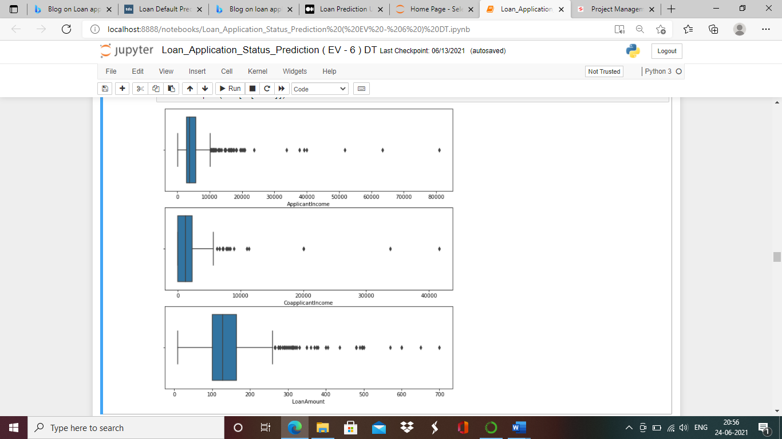

We can see huge amount of outliers are present in above columns, we will apply soft caping to treat them individually by quantile method.

### **Quantile**

Treating the q4 set of the columns with soft capping method.

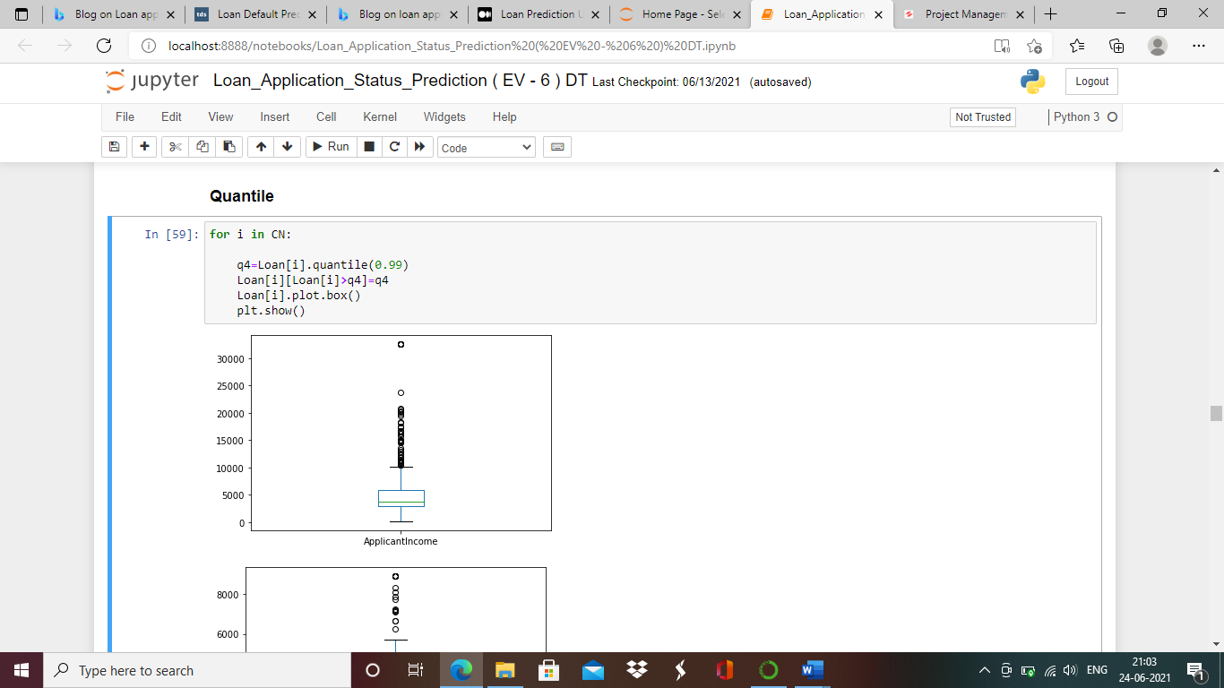

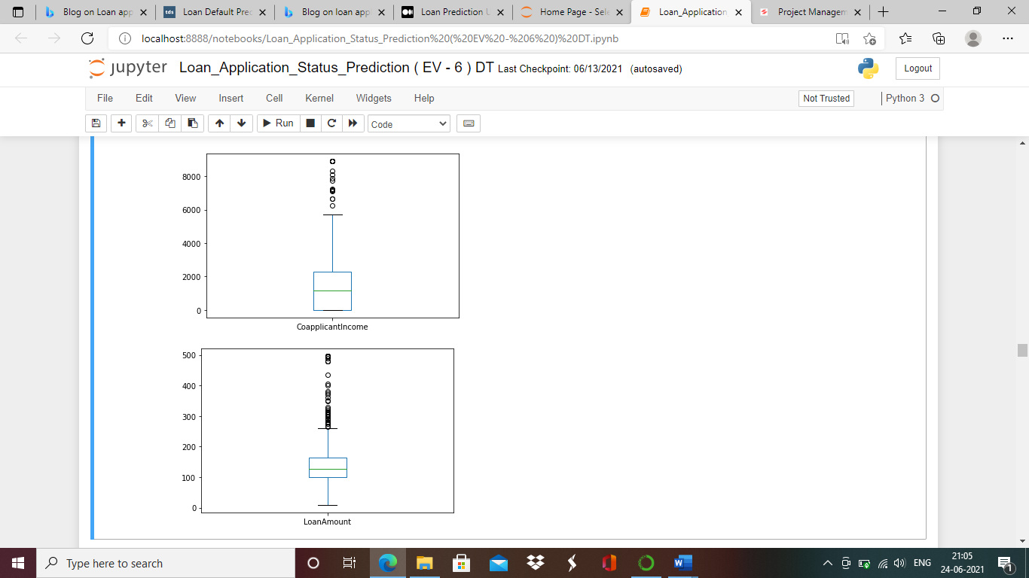

From above plots we can conclude most of the outliers are treated from required columns.

**Encoding**

All object data type of columns to be converted from categorical variable to numerical numbers.

We will perform that with encoding method.

We will apply One hot encoder on Gender,Married,Education,Self_Employed,Credit History,Property_Area columns.

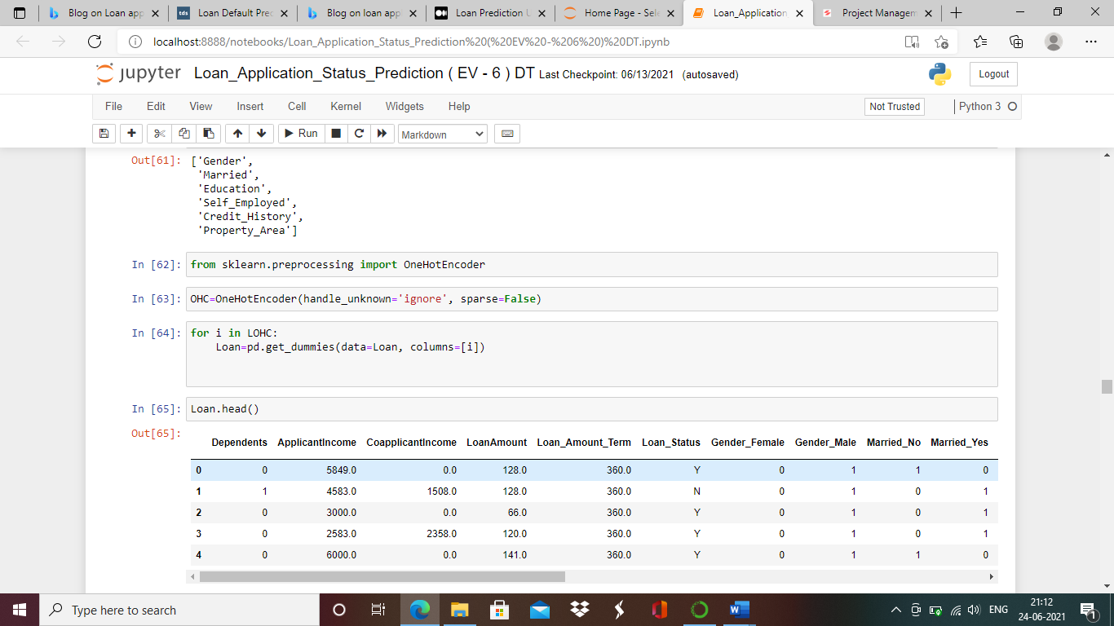

We will apply Label Encoder on Dependents,Loan_Amount_Term and Loan_Status columns.

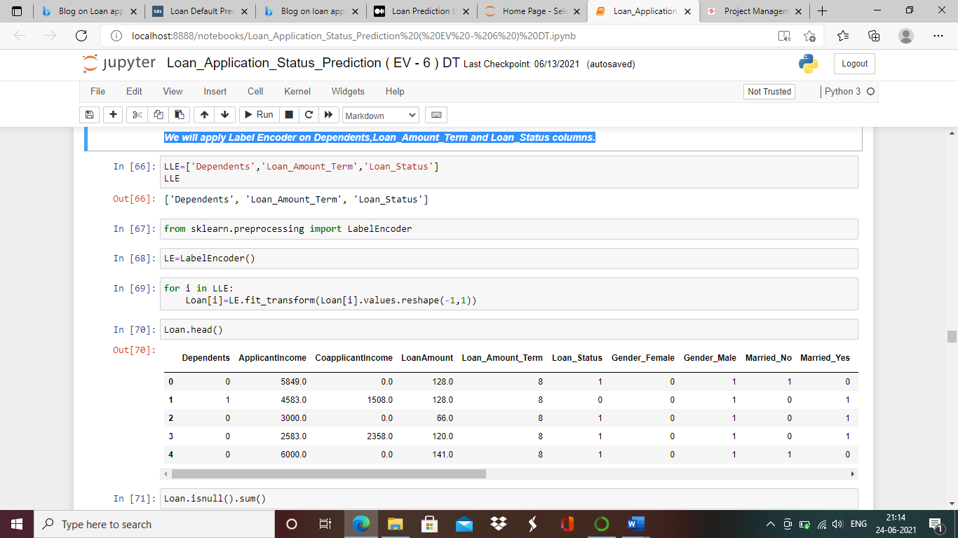

We have treated all the missing values form dataset,removed outliers and performed encoding an all categorized column.

**Data Splitting :**

We will split the data in X and Y.

X set contains all the independent columns and Y set is dependent column.

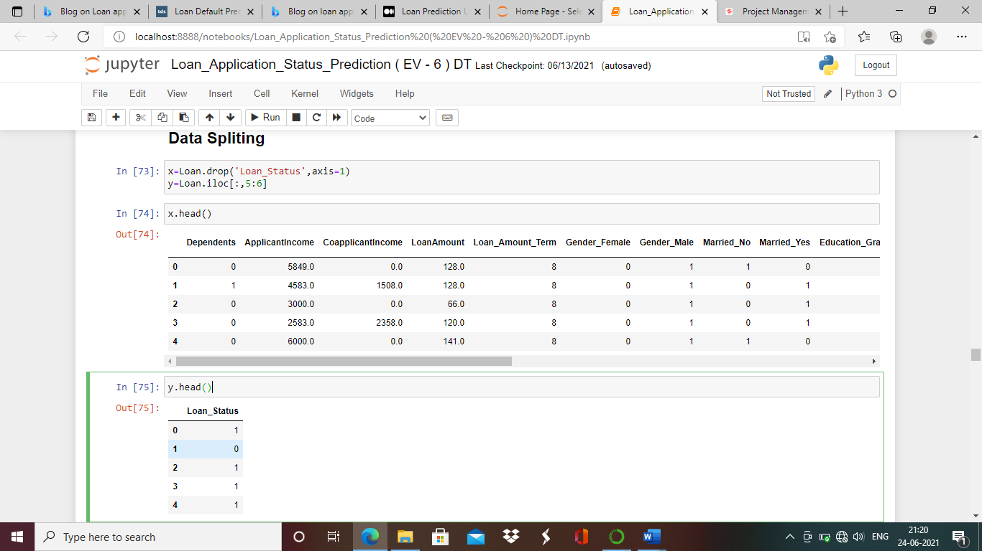

We had seen earlier while treating misising values our Y set is imbalanced, and we need to correct this imbalancing for better performance of models.We can correct this imbalacing with oversampling method or under sampling .In this dataset we need to apply oversampling as Y set has 70% Non defaulter and 30 % defaulters, also rows in this dataset are very limited and under sampling will cause to lossing of the data .Which inturn can lead to impacting the model performance.

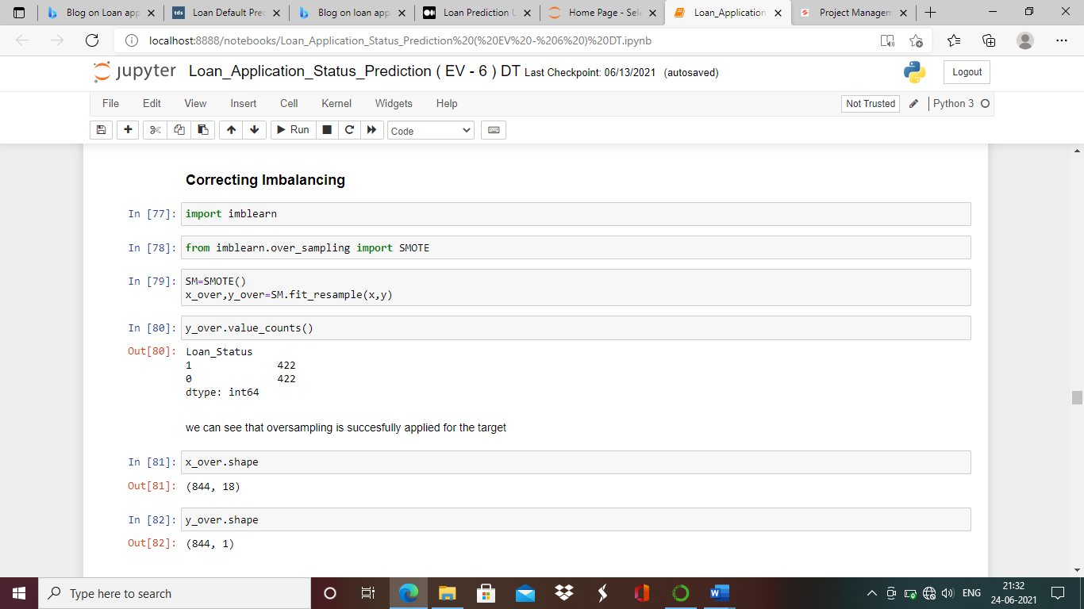

After appying over sampling our X and Y set size rows have increased from 614 to 844.

**Skewness**

Skewness measures the deviation of a random variable’s given distribution from the normal distribution, which is symmetrical on both sides.Models don’t run good when data is skewed and the reason behind this is that the tapering ends or the tail region of the skewed data distributions are basically the outliers in the data and it is known to us that outliers can severely damage the performance of a statistical model the best example of this being regression-models which show very bad results when trained over skewed data.Hence, before running X set the we should check the skewness of each numerical column and not categorized column.

Skew value od column should aleways be between -0.5 to 0.5.

We will check the skewness of each column now.

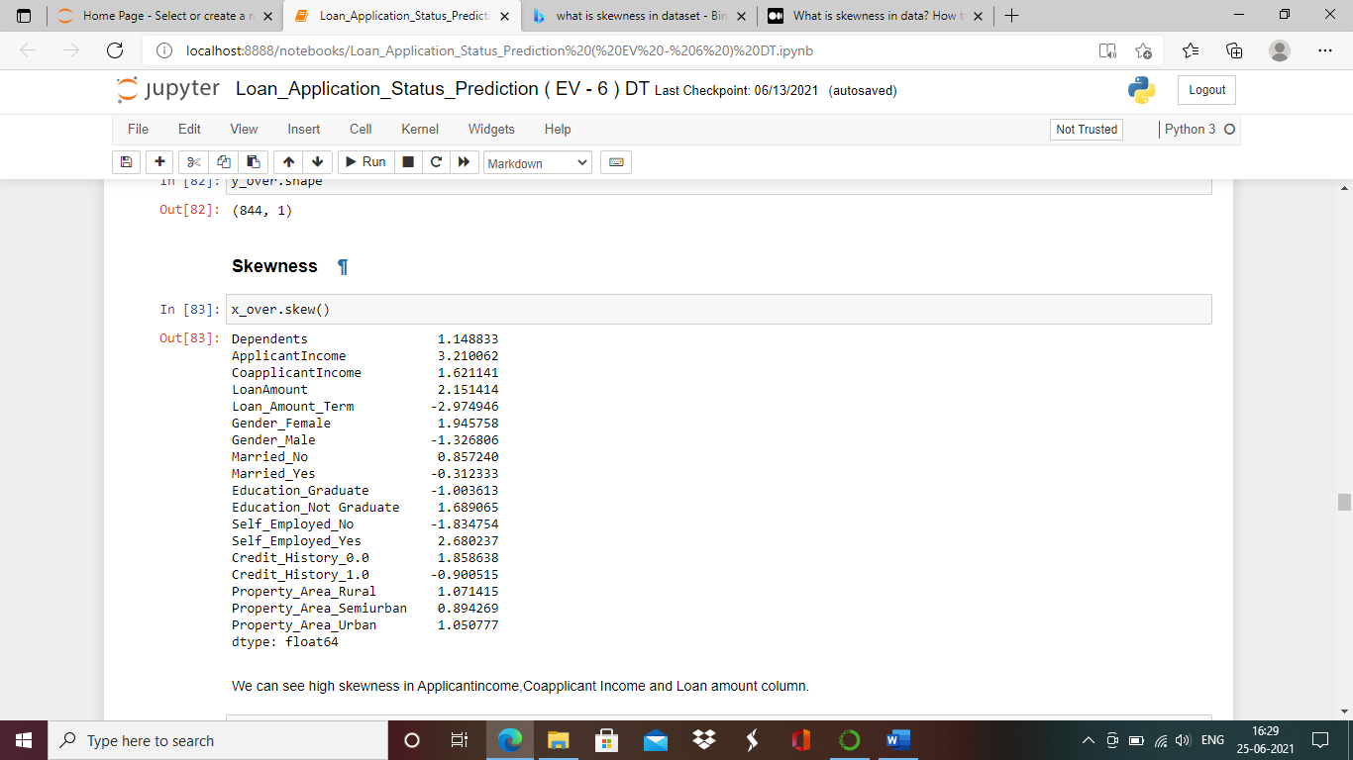

Skewness is more than the limit in Applicant income, Co-applicant Income and Loan amount column.

To treat the skewness of column there are various methods like log transform, square root transform and box-cox transform. First, we will try correcting the skewness with log transform method for all three columns and if we still observe the skewness than we can use square root transform and at last box cox method.

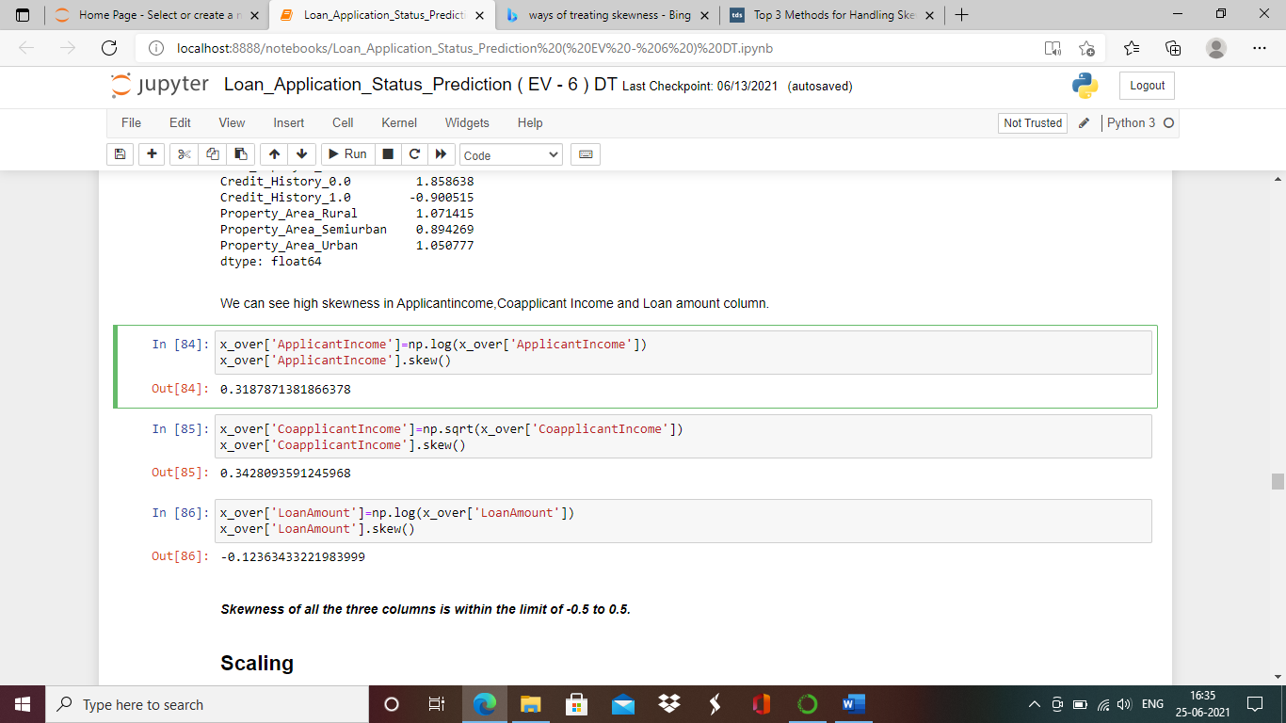

Using log tranform we have corrected skewness of Applicant Income and Loan Amount.

Using square root transform we have corrected skewness of Co applicant Income.

Now skewness of all the coulmns is with in the limt.

**Scaling**

Scaling is the final treatment we need to do before executing the data in model for prediciotn.

Scaling is performed when there is vast difference in range of data within column.There are various methods we can perform feature scaling. (i.e Minmax scaler ,standard scaler,Robust scaler etc.

We are using Min max scaler for data set as standard deviation is small.

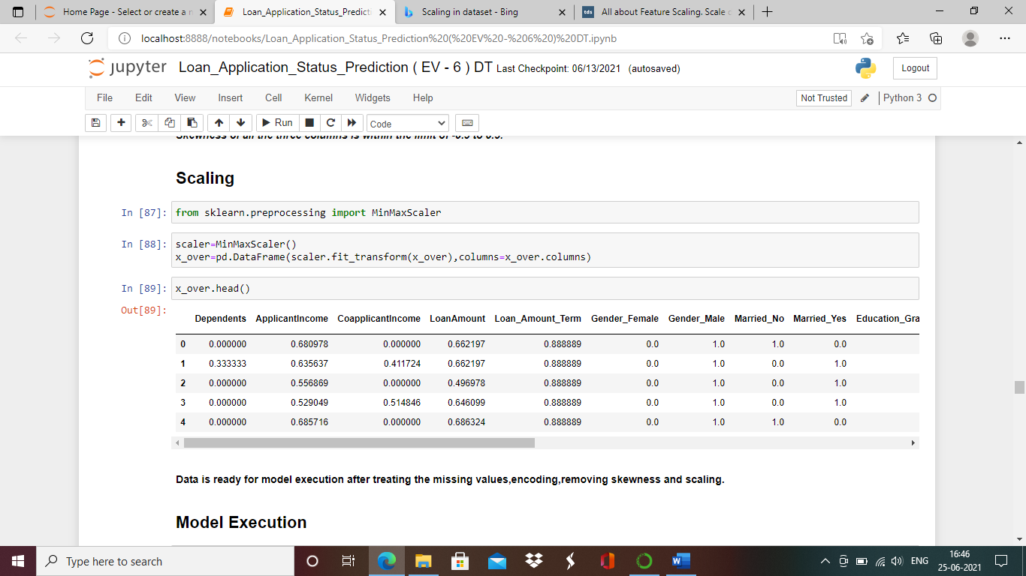

Data is ready for model execution after treating the missing values, encoding, removing skewness and scaling.

**Building Machine Learning Models**

For model execution we have to split the data in train and test data which plays a very critical role in model performance, as imbalanced fitting of test and train data can impact model performance. We should always try keeping training data close to 70% for better performance.

This being a classification problem we can use various models like logistic regression, Decision Tree Classifier, Random Forest classifier, Ada boost classifier, XgBoost classifier etc.

I have tried running all the above mentioned model and also have also applied hyper parameter tunning to improve the performance of each model. After running al modle I have to come to conclusion at logistic regression model was best performing model ,we will check the performance and details.

Initially we will check the best random state for model performance using logistic regression.

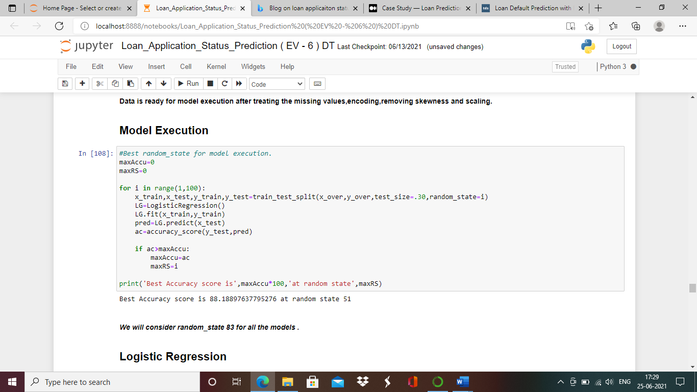

Best accuracy score we are getting is 88.58% at random state=45.

Logistic Regression.

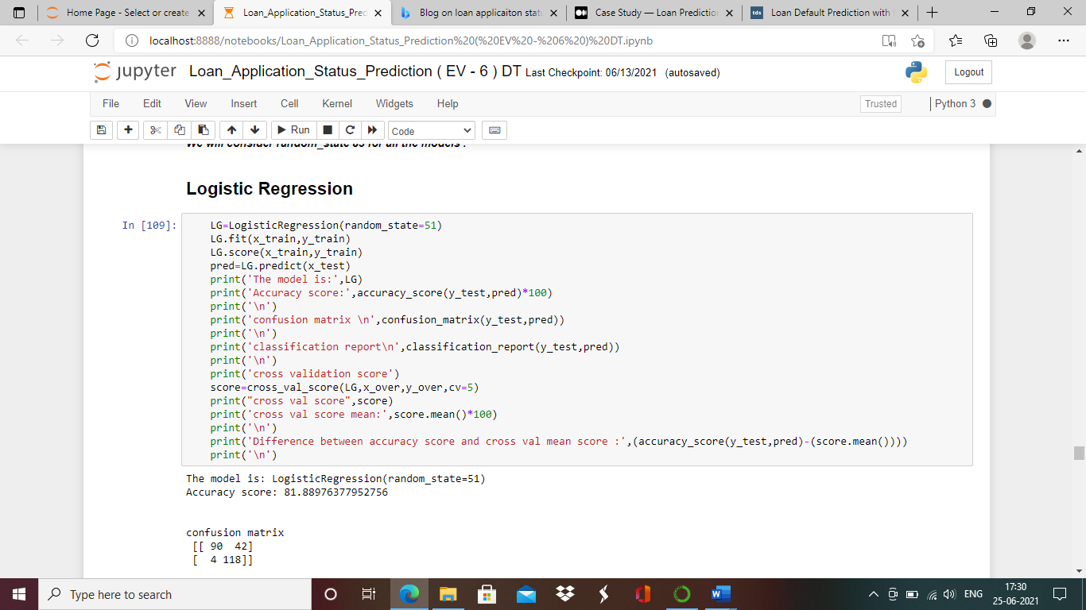

Above is the code for logistic regression model to check accuracy score of test model, confusion matrix and classification report .We will also check cross validation score of this model at different cross folds.

Finally, we check the difference between accuracy score and mean cross validation score, least the difference between them better is the model performance.

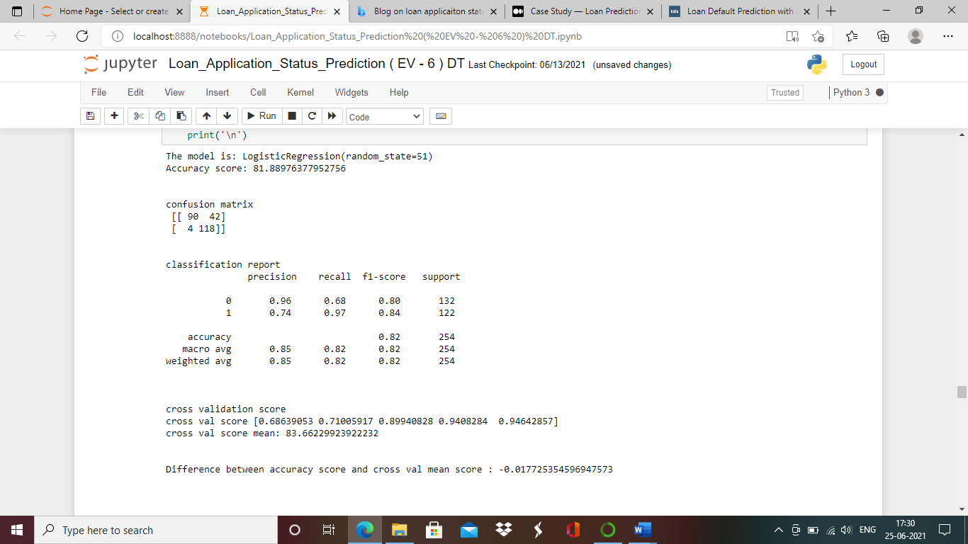

Let’s apply hyper parameter tunning using grid search cv for logistic regression

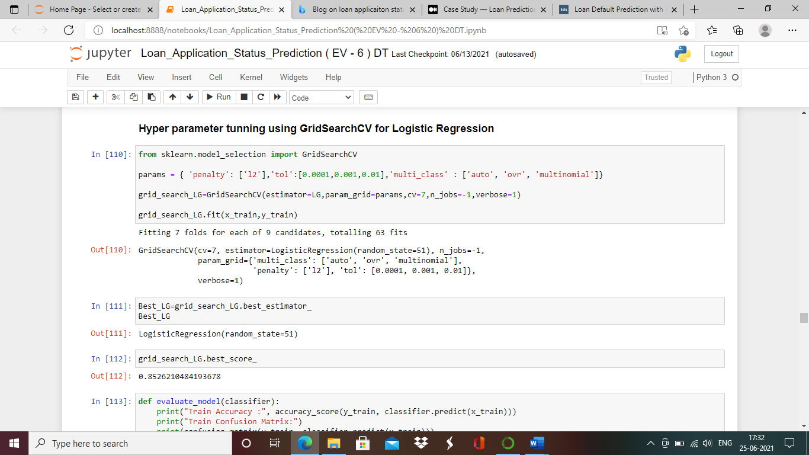

Code for logistic regression after applying hyper parameter tunning

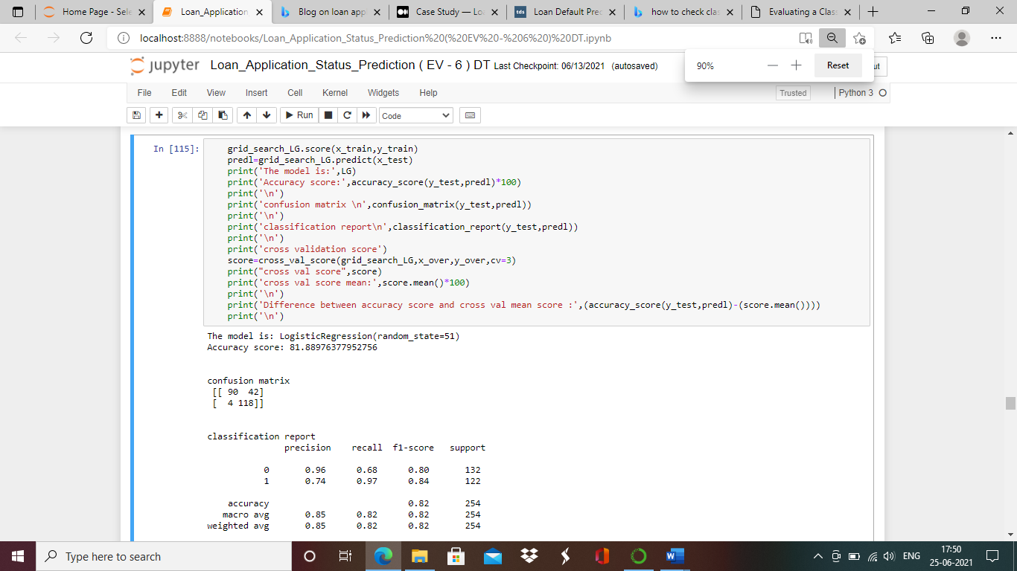

After running the above code we can conclude that

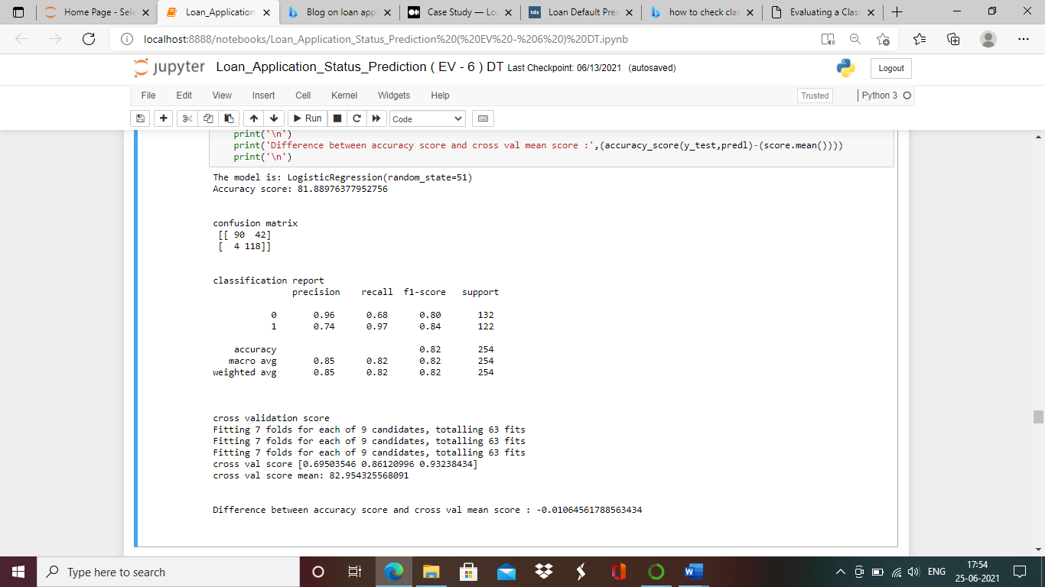

Logistic regression is giving us really good accuracy for test data of 81.88% at 3 cross folds also F1 score is good of .80.

AUC ROC CURVE (AREA UNDER CURVE)

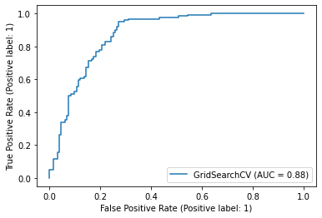

AUC score is also good, concluding better prediction of values.

**Concluding Remarks**

In Loan application status prediction dataset, we have introduced the whole pipeline of an end-to-end machine learning. We have described the dataset, and explored all the variables in the dataset. Checked if there are any missing values. Exploratory data analysis is performed using univariate, bivariate and multivariate columns for better understanding of data.

Data featuring is performed by treating the missing the values, checking correlation between columns, encoding all the alphabetical columns to numerical. Outliers are cleared in dataset with quantile method and made ready to run the model. We have also found the label column was imbalanced which is corrected with oversampling method. We have run various models to find the best model and found loan application status prediction has used logistic regression model as best model to predict the defaulter. This model has achieved the accuracy score of 81.88% for test dataset after applying hyper parameter tunning. F1 score is also observed good of 0.80.

**Thank you!!!!**

**DATASET -2**

**FLIGHT FARE PREDICTION**

**Problem Statement:**

Flight ticket prices can be something hard to guess, today we might see a price, check out the price of the same flight tomorrow, it will be a different story. We might have often heard travelers saying that flight ticket prices are so unpredictable. Here you will be provided with prices of flight tickets for various airlines between the months of March and June of 2019 and between various cities.

Size of training set: 10683 records

Size of test set: 2671 records

This Train dataset includes variables like:

FEATURES:

Airline: The name of the airline.

Date_of_Journey: The date of the journey

Source: The source from which the service begins.

Destination: The destination where the service ends.

Route: The route taken by the flight to reach the destination.

Dep_Time: The time when the journey starts from the source.

Arrival_Time: Time of arrival at the destination.

Duration: Total duration of the flight.

Total_Stops: Total stops between the source and destination.

Additional_Info: Additional information about the flight

Price: The price of the ticket.

**Data Analyzing:**

We will import all the required libraries to call the dataset and execute the models.

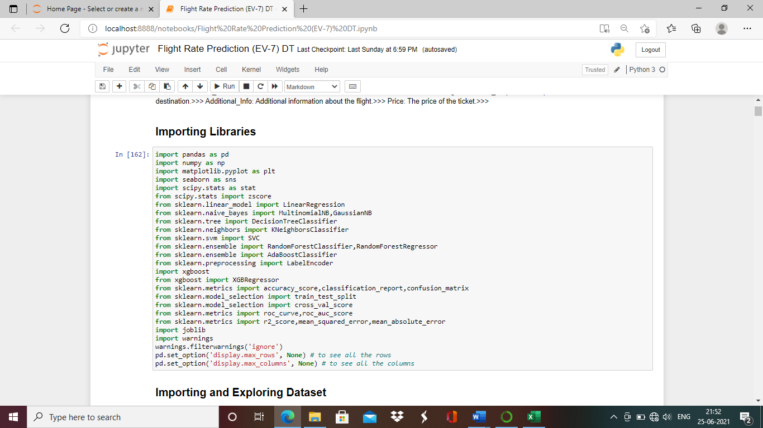

Importing the dataset for analyzing .

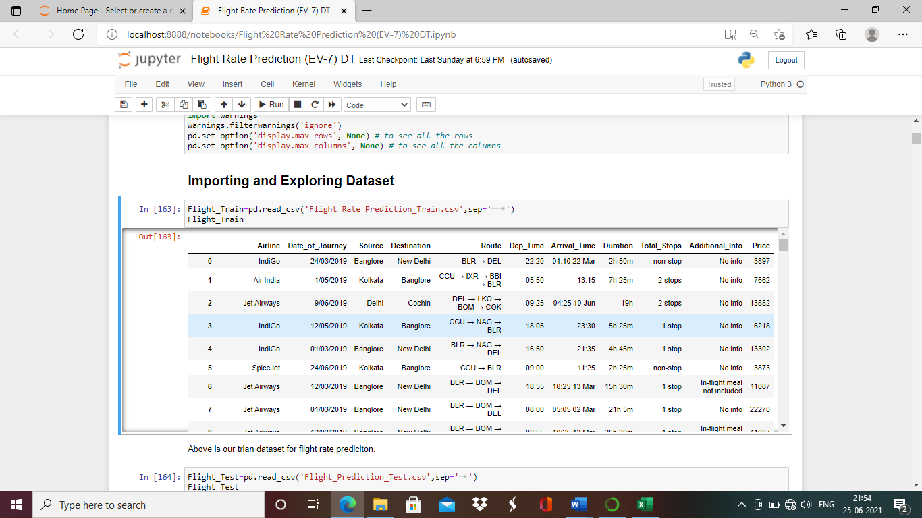

Dataset is called as Flight_Train further for model execution.Now lets check number of rows and columns in dataset.

Check number of rows and columns in dataset.

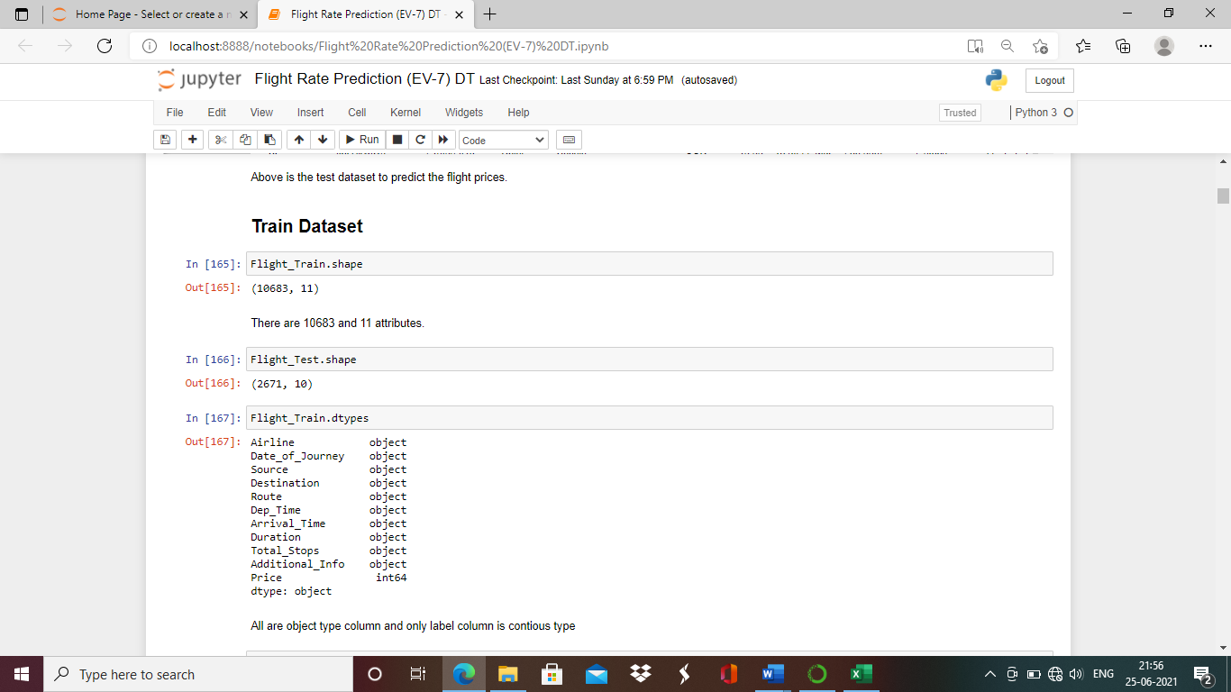

There are 10683 rows and 11 attributes in this Flight_Train dataset.

Check the data types of all the columns.

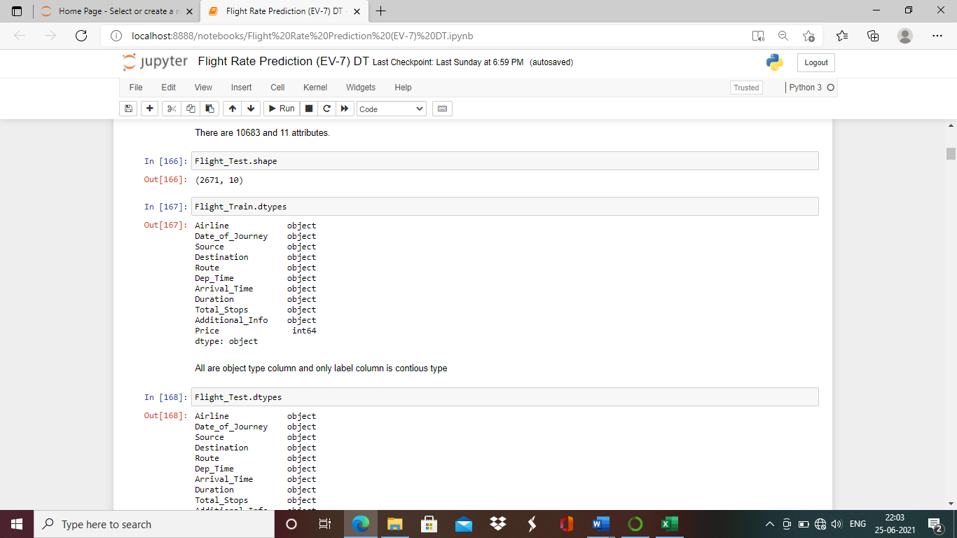

All the columns in this dataset are object type and only target column is integer type.

Let’s ,check if any null values are present in dataset.

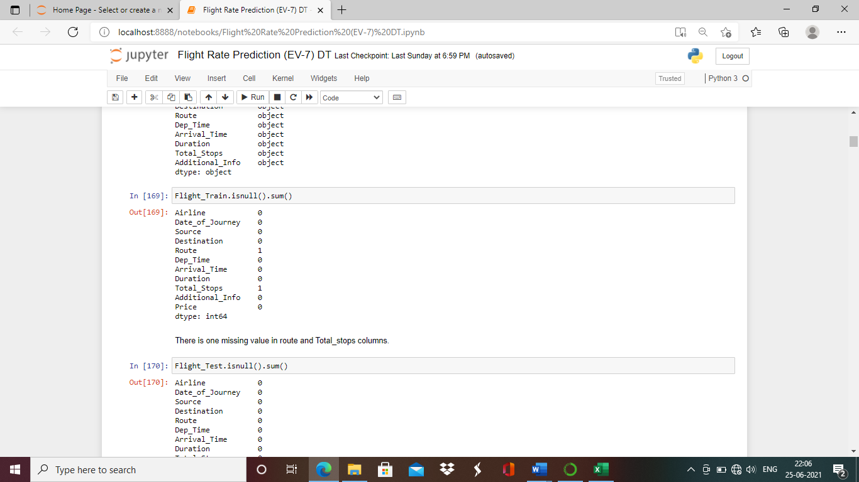

We can conclude from above code that only route and total stops column have null values .

Each of those column have 1 null vlaue.

Check the column names:

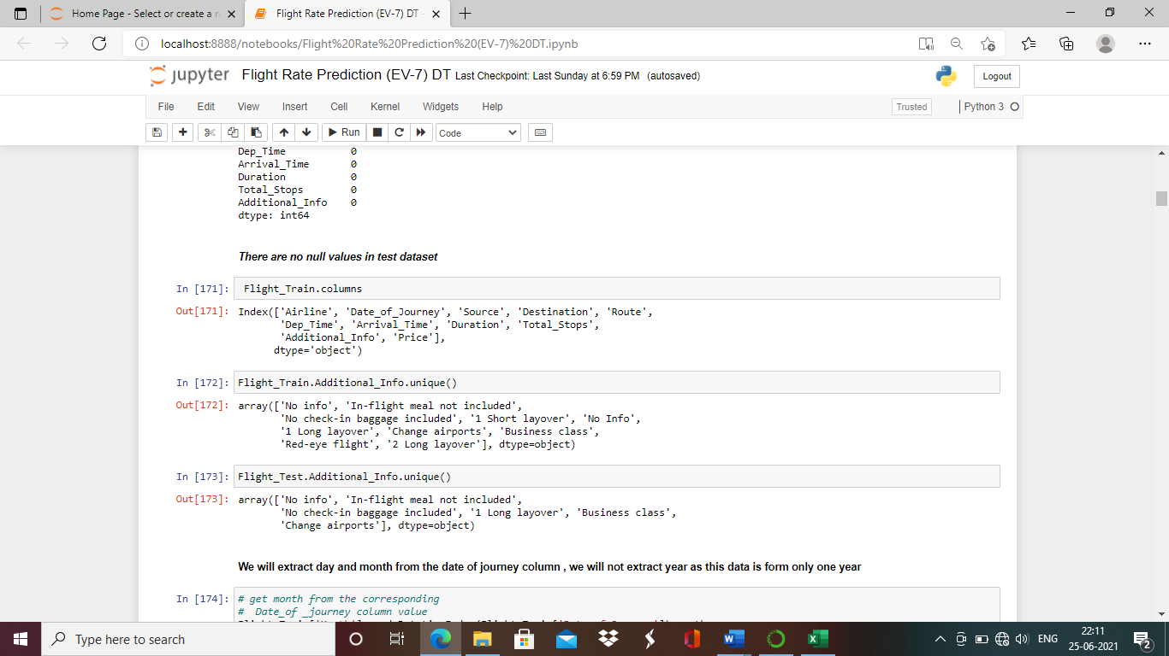

After importing and analyzing the dataset we could understand Airline column has categorical data,Date of journey has data in date format which we will split in month and year for better analyzing,Source & destination is categorical column,Route is 2 or 3 places with special character which also we will have to treat for better analyzing,Dep_Time,Arrival_Time has data in time format which is not suitable to be sused without treating hence we will split data in mins and hours column,Total_stops and Additional_info has categorical data.

**Date Of Journey**

We will extract month from the date of journey column.

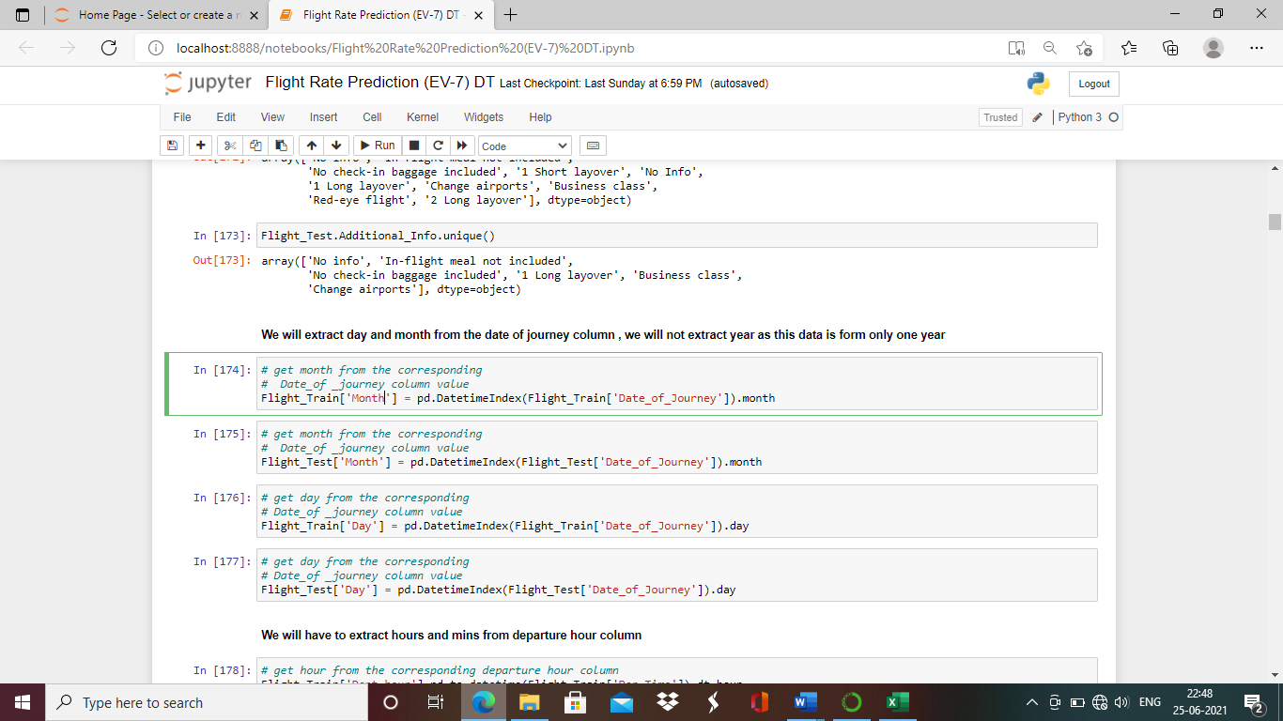

We will extract day from the date of journey column.

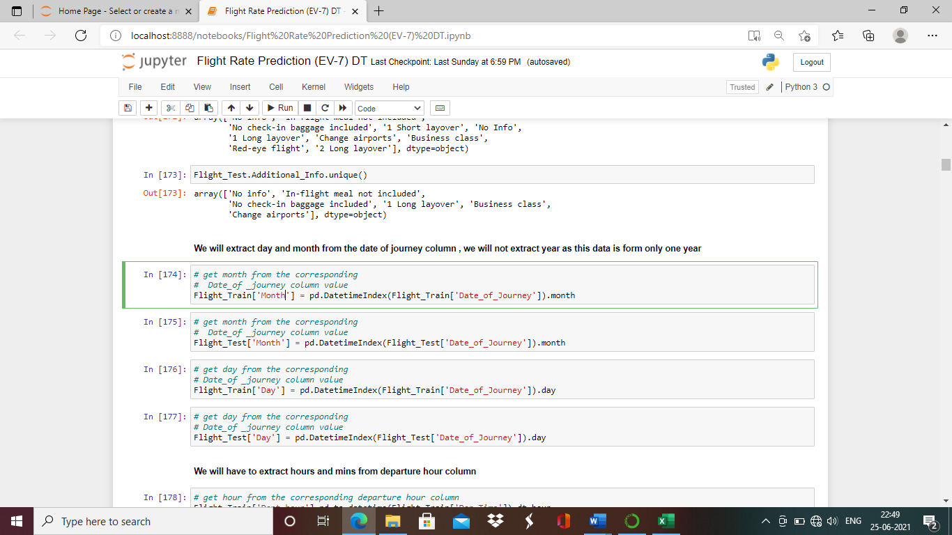

We will not extract year from the date of journey column as this data is only for one year.

**Dept_Time**

We will extract hours from departure time column.

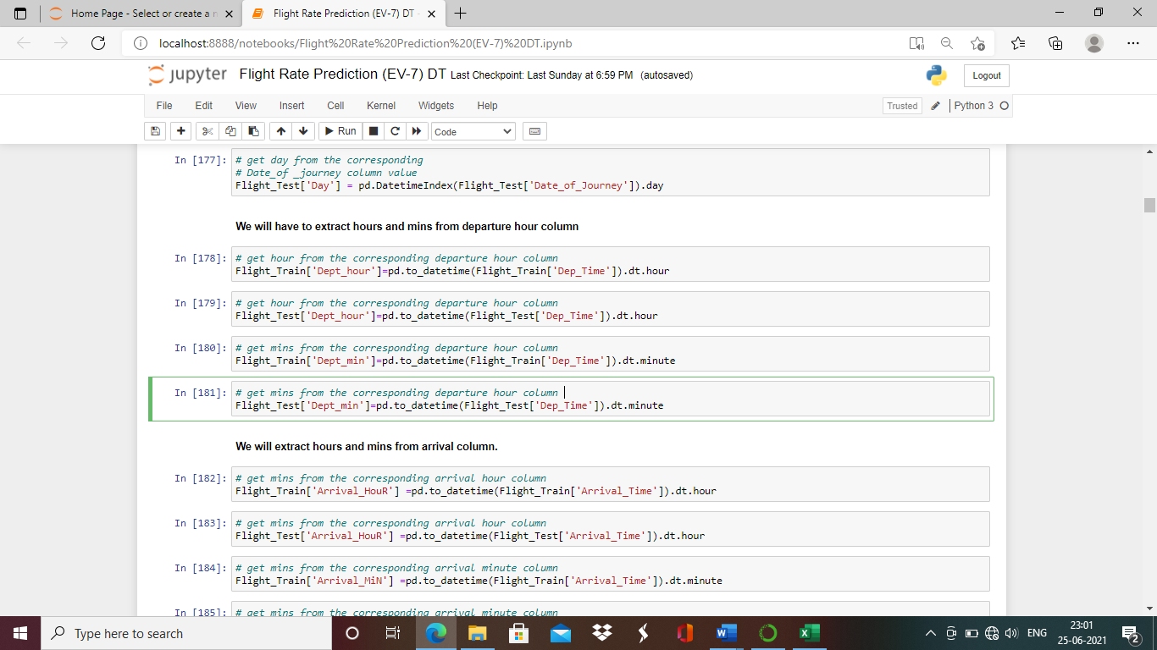

We will extract hours from departure time column.

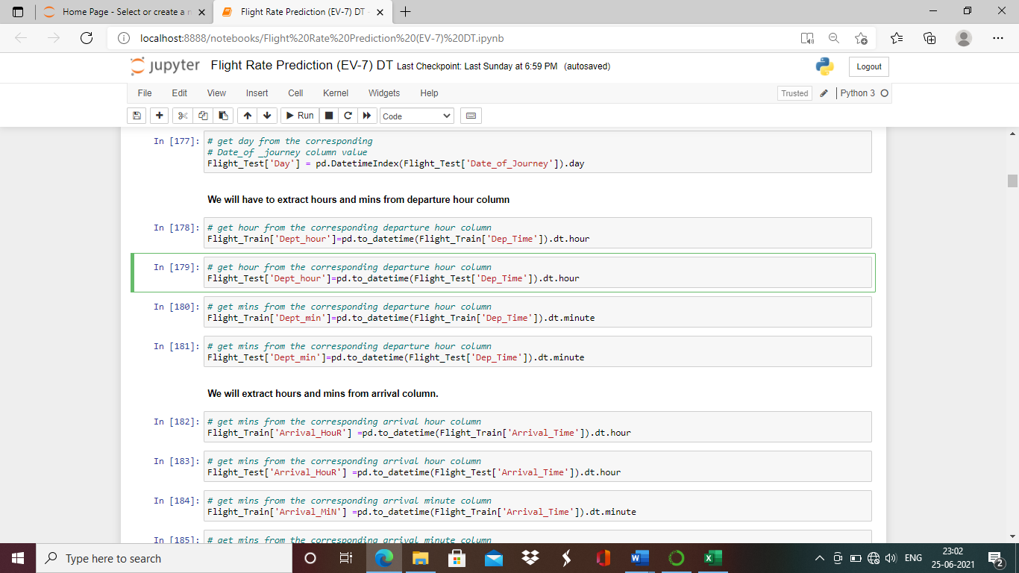

**Arrival_Time:**

We will extract hours from arrival column.

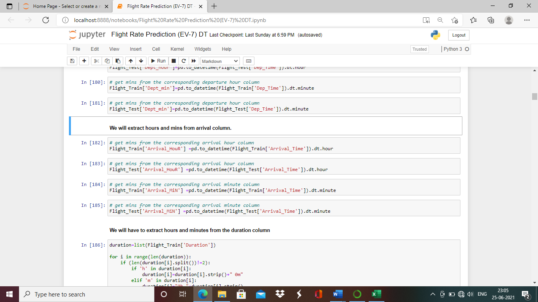

We will extract minutes from arrival column.

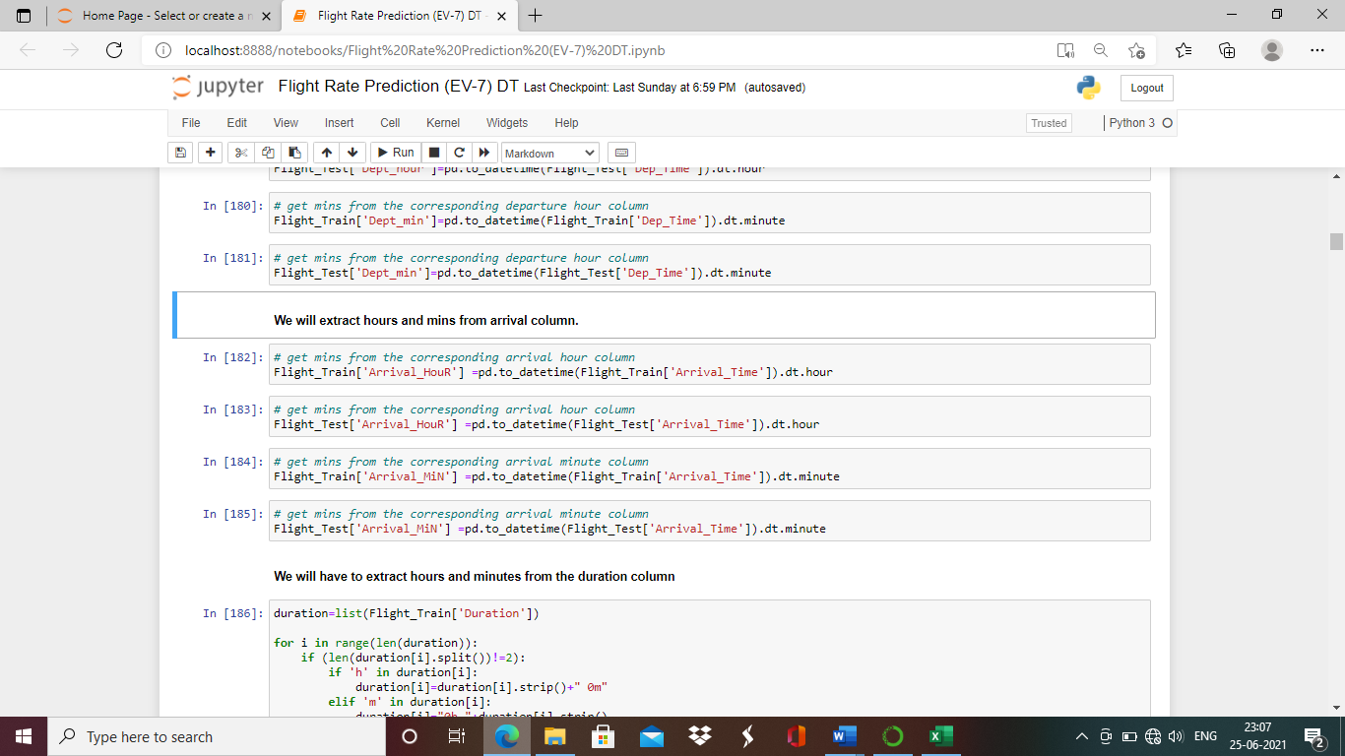

We will now extract hours and mins from duration column, but in this column time isn’t in same format as of arrival and departure time column.Hence we will make for loop .

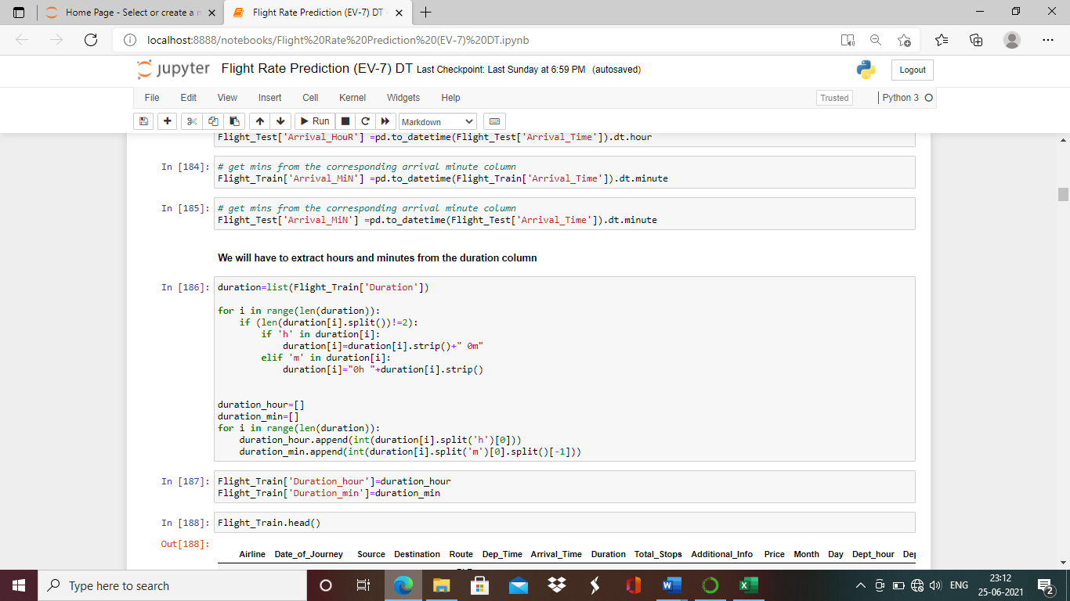

We will save hour and minutes from duration column in duration hour and duration min arrays.

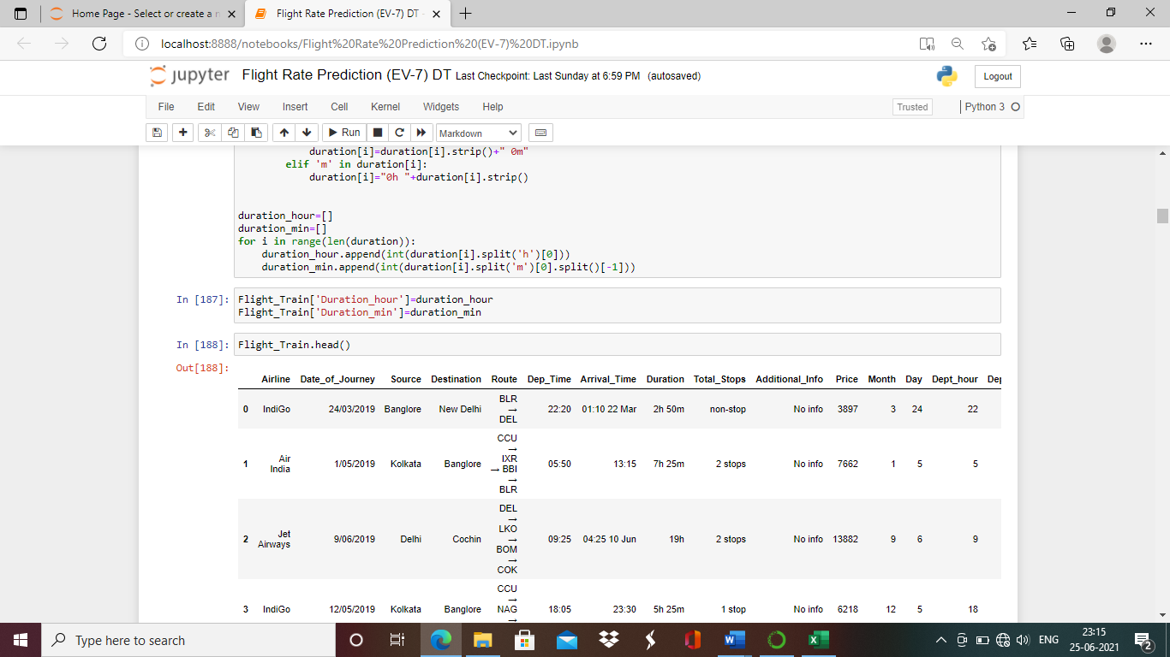

After splitting and extracting all the required data from departure time, arrival time, date of journey and duration columns, we will drop all the extra columns

Drop Date_of_journey.

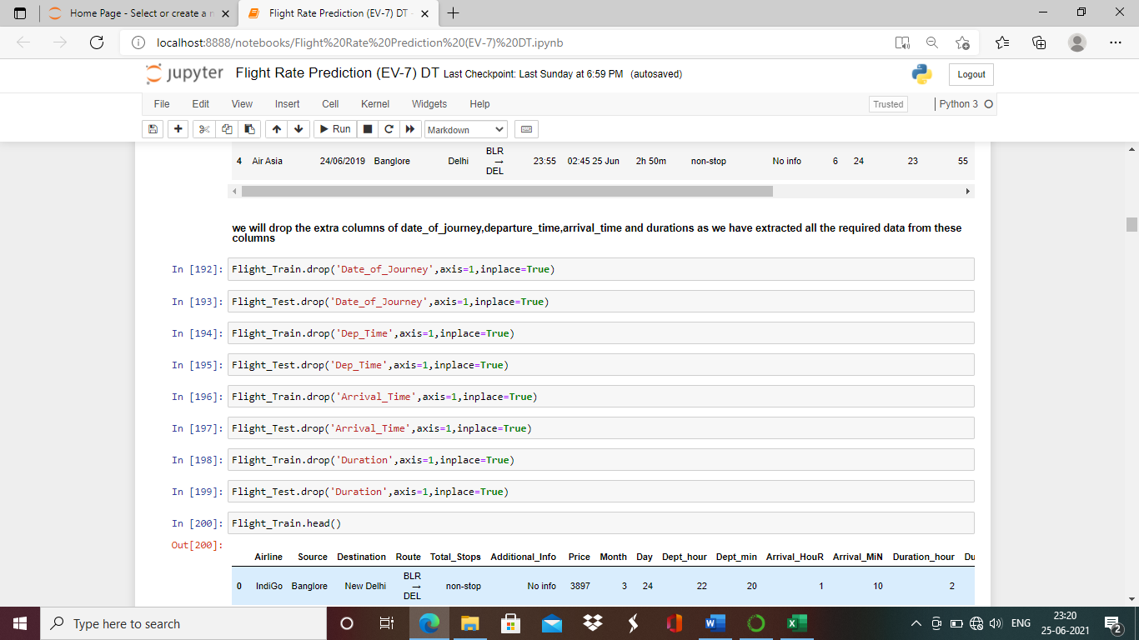

Drop Arrival_Time

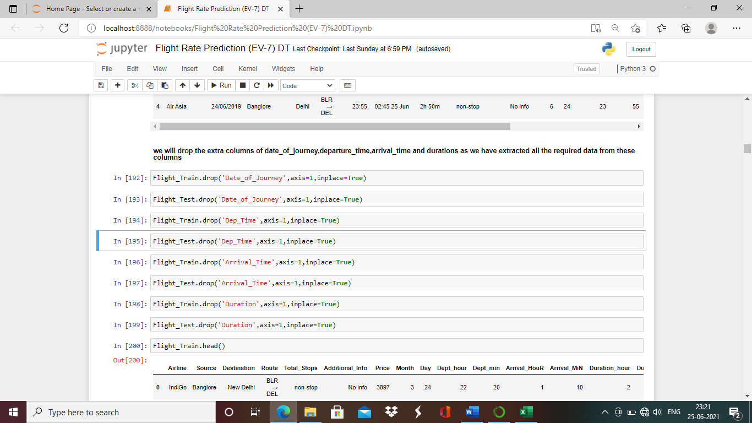

Drop Departure_Time

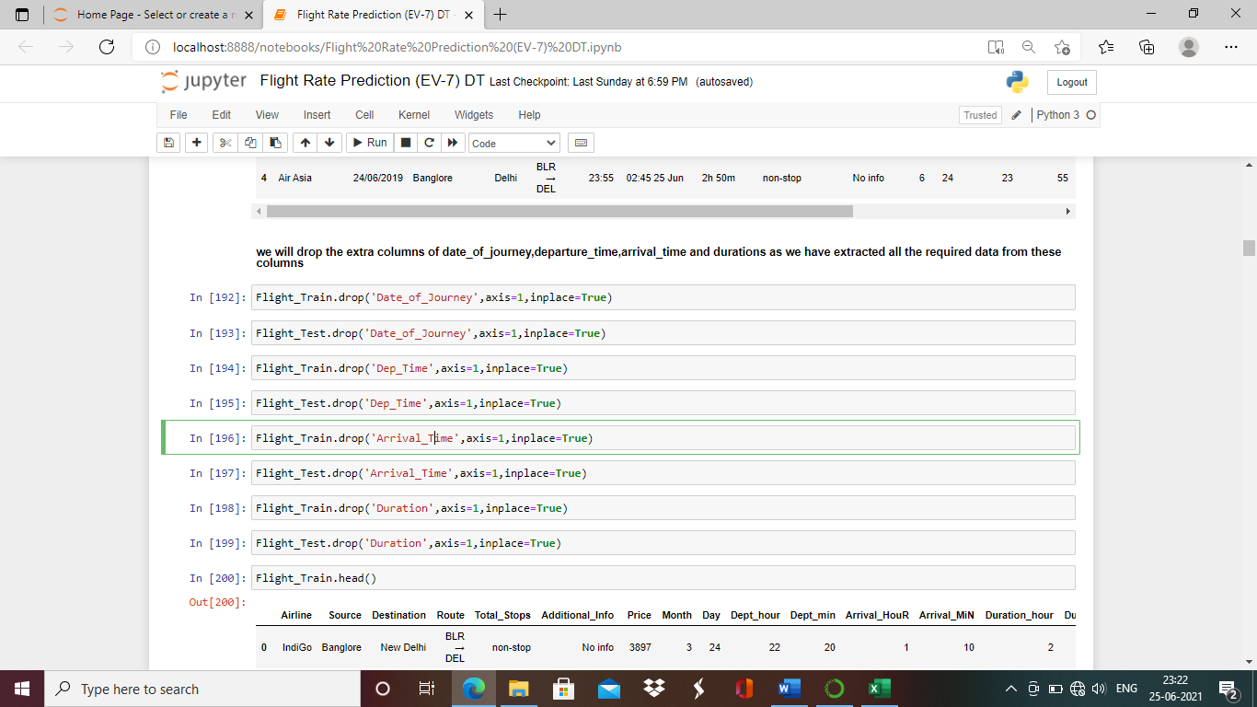

Drop Duration

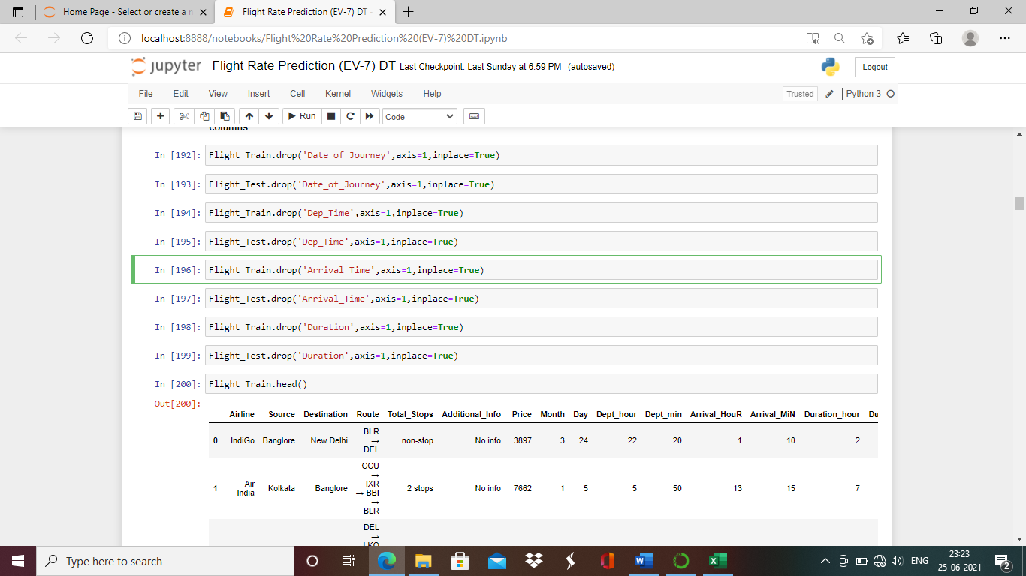

**EDA Concluding Remarks**

**Univariate Analysis**

**Violin Plot for Price :**

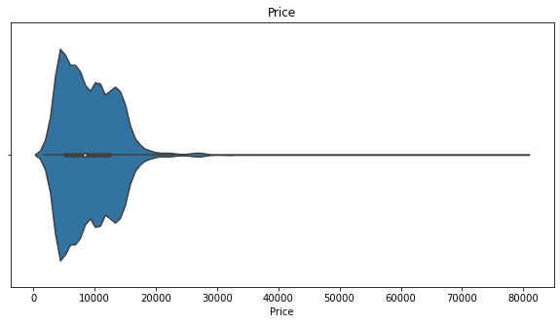

Observation:

Flight prices range highly from Rs:0 to 20000 and are peak at around Rs:6000.

**Count Plot for Destination:**

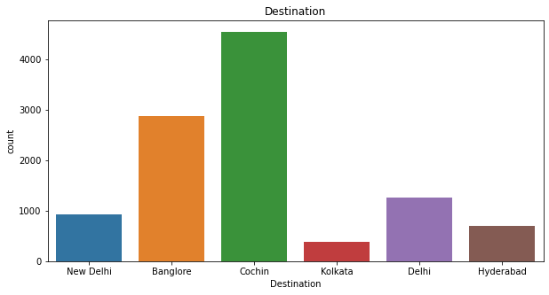

Observation:

1)Most of the flights are having final destination Cochin.

2)Lest flights in dataset have destination Kolkata.

3)Other destinations where flights are flying up to are New Delhi, Banglore, Delhi and Hyderabad.

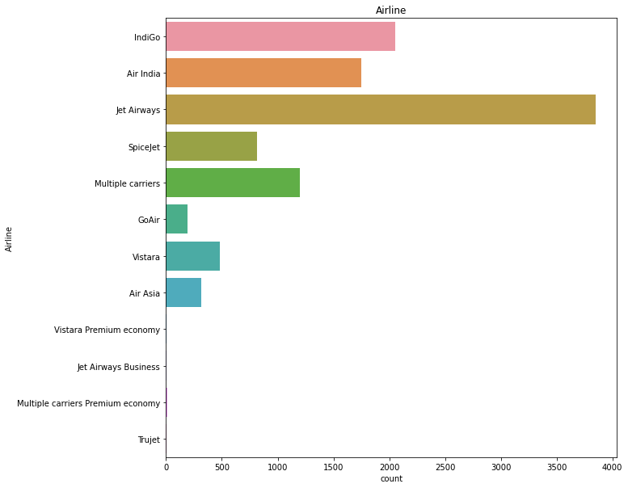

Observation:

1)Jet airways flights are the most in the dataset.

2)Vistara Premium Economy, Jet Airways Business Multiple carriers’ premium economy and Trujet are least flights in dataset.

3)Other flying flights are Indigo,Air India,Spicejet,Multiple carriers,GoAir,Vistara and Air asia .

**Count plot for Flight Source:**

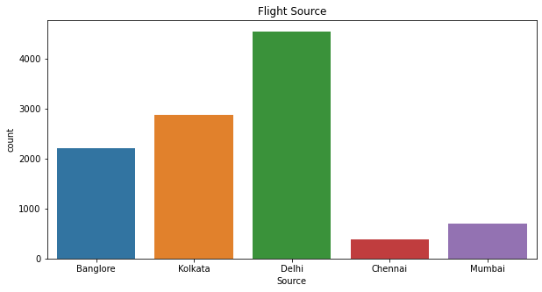

Observation:

1)Delhi is the source place for most of the flights in dataset.

2)Chennai is the source place for very flights.

3)Flights are also from Banglore ,Kolkata and Mumbai.

**Count plot for Total Stops :**

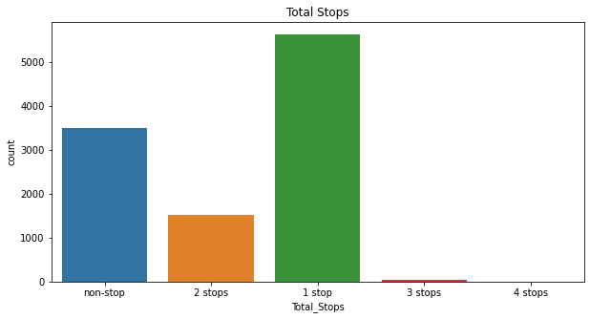

Observation:

1)Flights with 1 stop in the journey are the highest in dataset.

2)Non stop flights are the second highest in the dataset.

3)Very few flights are with 3 and 4 stops.

**Count Plot for Additional Info:**

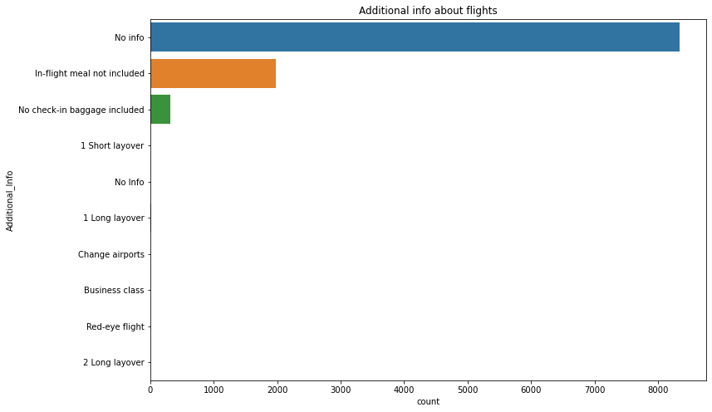

Observation:

1)Most of the columns are not giving us any info.

2)For few fights we get to know that meals is not included and also for few check in baggage isn't included.

3)Other info's what we have got can be considered as not essential.

**Count plot for Flight in Month:**

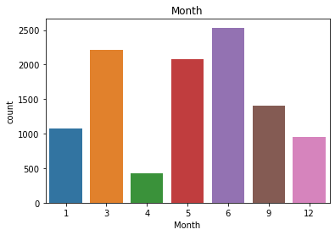

Observation:

1)We have data for most of the flights on june.

2)We have data of very few flights from month of april.

**Bivariate Analysis:**

**Strip Plot for Airlines and Price:**

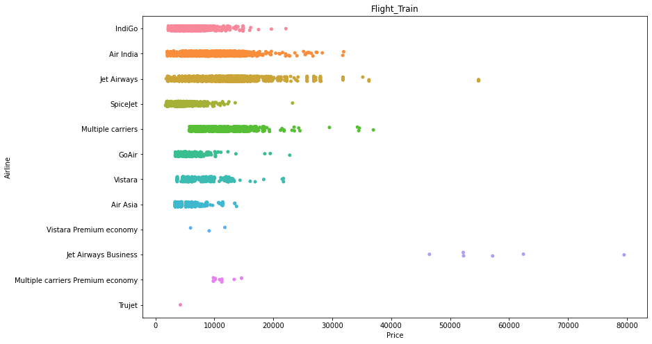

Observation:

1)Jet Airways Business ailine price are very high compared to other airlines.

2)IndiGo,Air India,Jet Airways,Spice jet have prices in similar range.

3)GoAir,Vistara and Air Asia have price range in almost similar range.

**Cat Plot for Total stops V/s Month:**

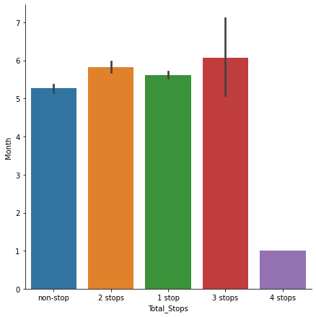

Observation:

1)Flights in month of jan are having large number of stops.

**Strip Plot for Destination v/s Price**

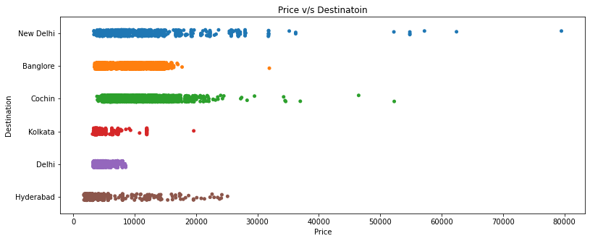

Observation:

1)The price of flights flying to Delhi is high.

2)Flights with destination kolkata have least fare.

**Strip Plot for Source v/s Price:**

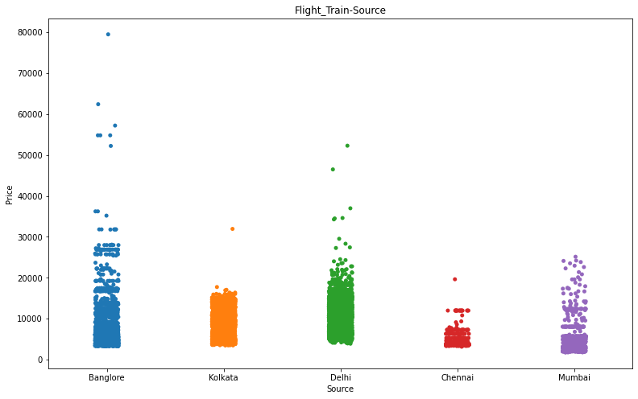

Observation:

1)Charges are at higher side person is flying from Bamglore.

2)Flights taking off from delhi are at second number after banglore in terms of flight charges.

3)Flight flying from Mumbai have the cheap prices

**Cat Plot for Month v/s Price**

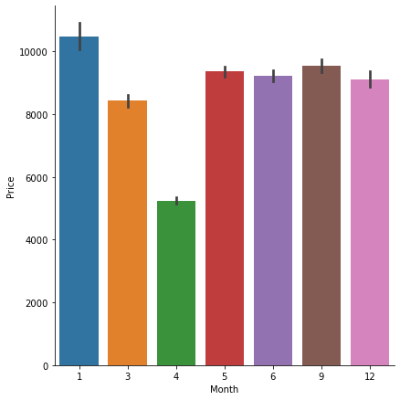

Observation:

1)Flight prices are high in month of jan.

2)Flight prices are least in month of april.

3)Flight prices are similar in month of june,sept and december.

**Scatter Plot for Dept_hour v/s Price**

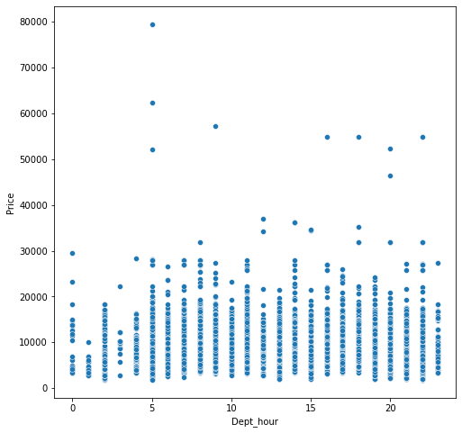

Observation:

1)Flight prices are less during late nights and early mornings.

**Cat plot Total stops v/s price using box pattern:**

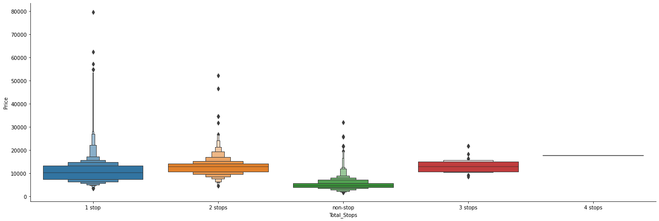

Observation:

1)Prices are high with 1stop.

2)Flights with no stop tend to have best price.

**Cat Plot for Airline v/s Price:**

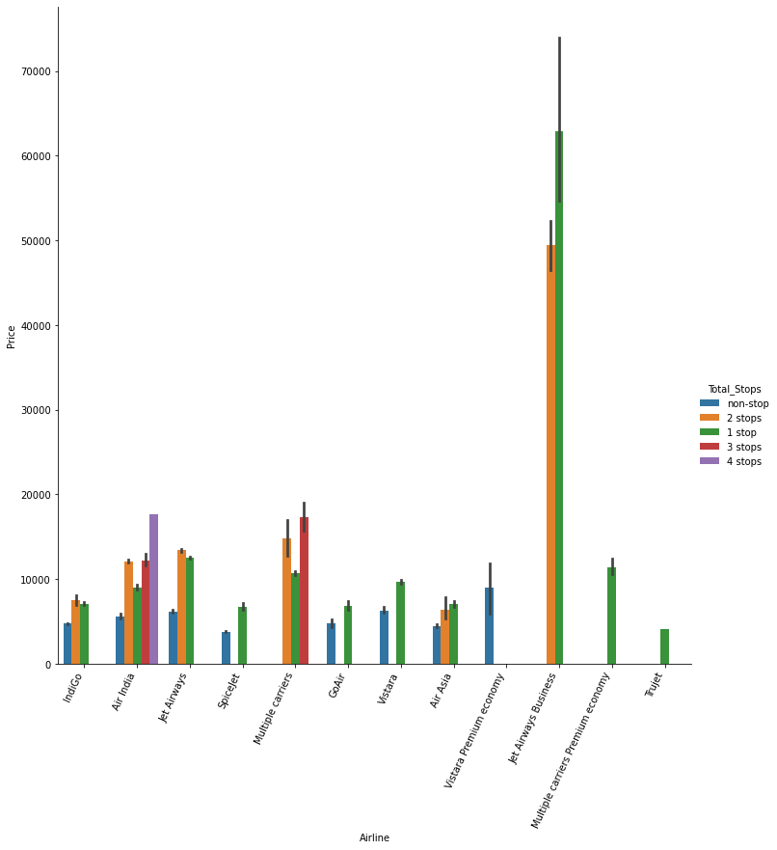

Observation:

1)Air India and Multiple carriers are the only airlines with 3 stops.

2)Trujet Multiple carriers premium economy airlines have flights with 1 stop and Vistara airlines have flights with no stops.

3)Only Air India has got flights with 4 stops.

4)Spice jet, Go Air, Vistara have flights with no stop or 1 stop.

**Multivariate Analysis**

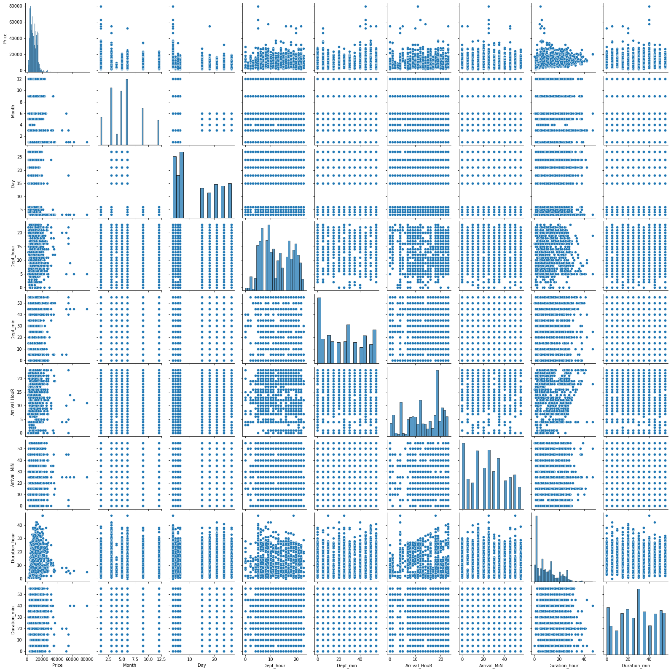

**Pre-processing Pipeline**

Treat the missing values.

#### We will replace the NaN value in Route column.

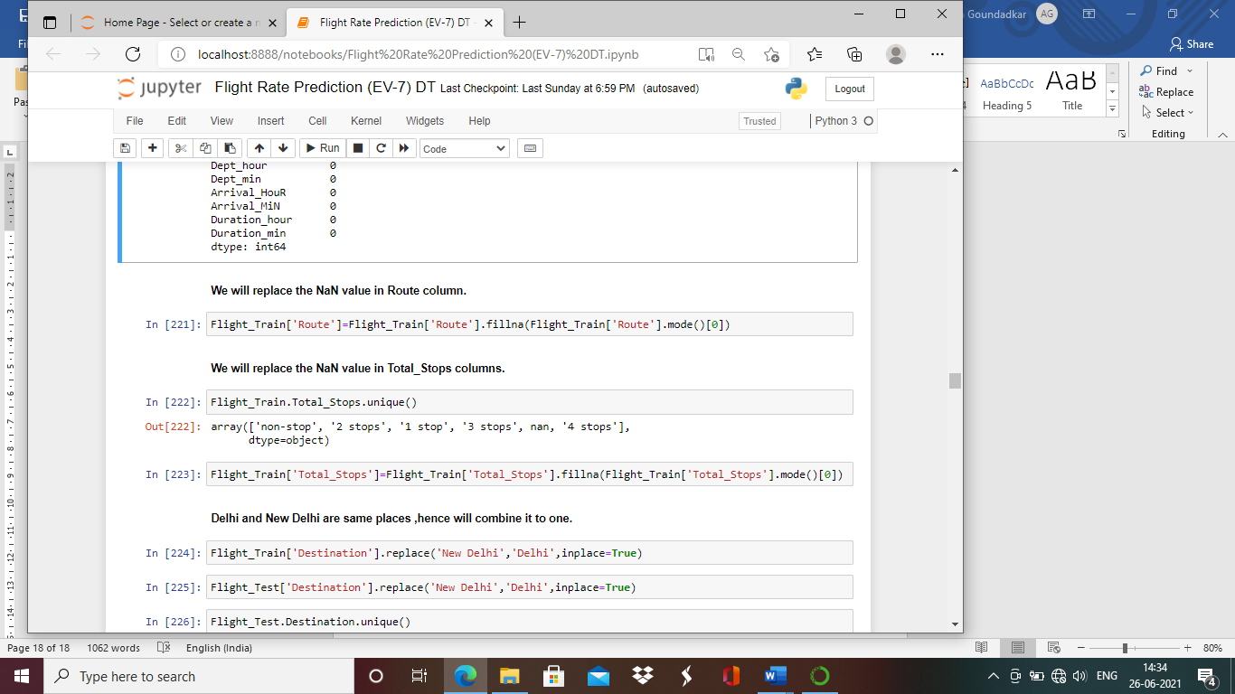

#### We will replace the NaN value in Total_Stops columns

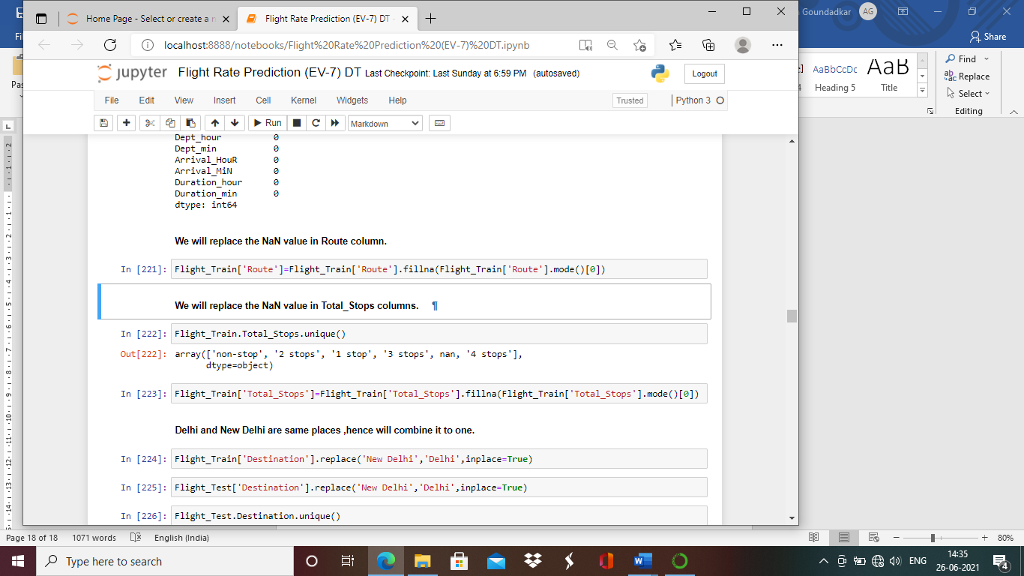

While performing EDA we had noticed there are two variables New and Delhi, which are actually same place. Hence, we will replace new Delhi with Delhi.

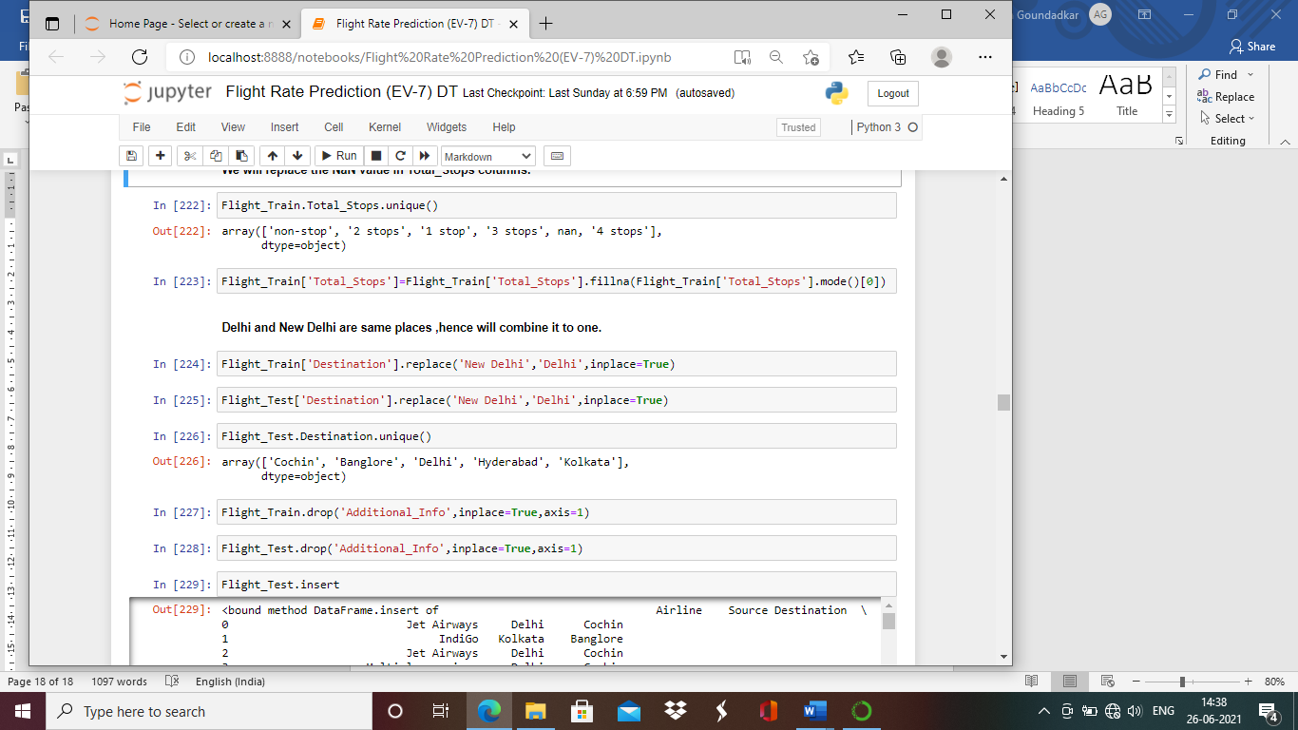

Also after doing EDA we can coclude the Additionla_Info column has 80% No_info data which is not helpful for model prediciton.

We will drop Additional_Info column.

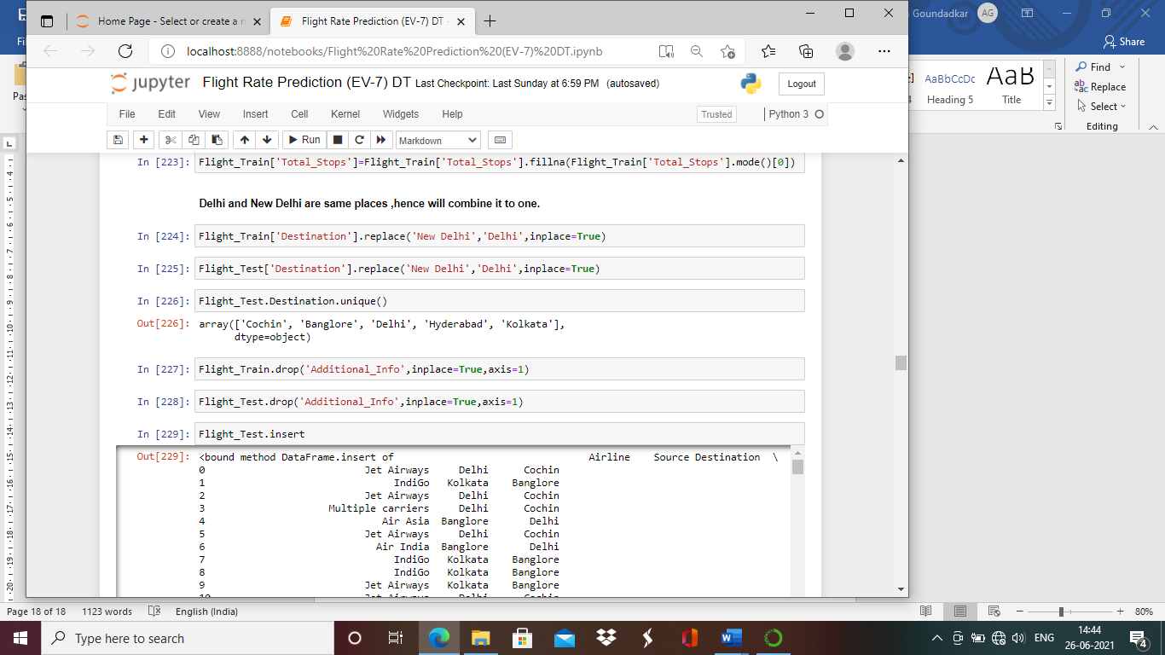

Checking if all null values are cleared from dataset.

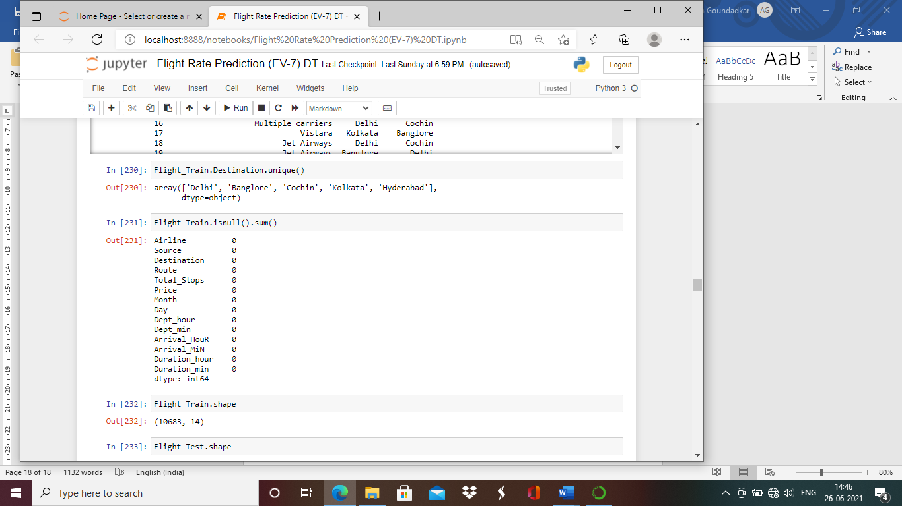

No null values in dataset.

**We will check correlation of the columns**

Below is table justifiying the correlation of the columns.

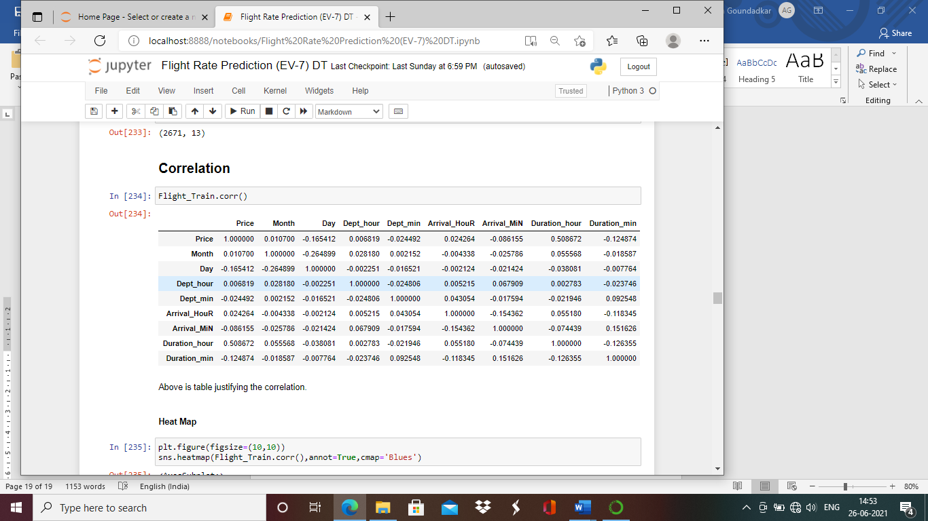

For better understanding of the correlation between columns we will plot the correlation with help of heatmap.

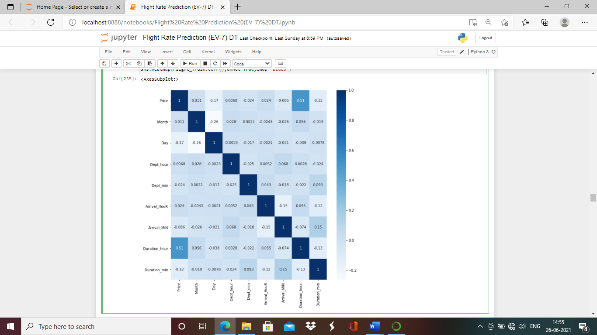

Observation:

1)Duration_hour and price are most correlated columns in the dataset.

2)Day and month are negatively correlated columns.

**Outliers**

Let’s treat the outliers in Flight_Train dataset. Outliers are to be treated only from numeric and continuous type of columns.

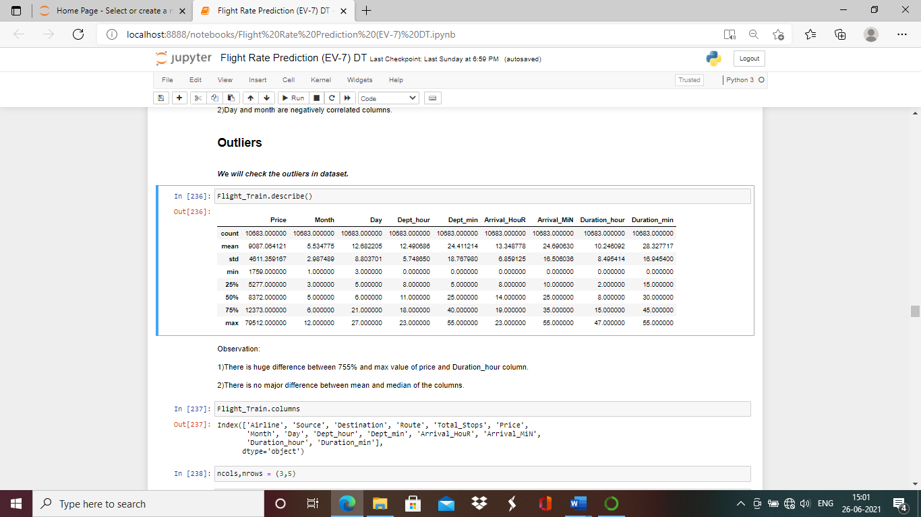

Observation:

1)There is huge difference between 75% and max value of price and Duration_hour column.

2)There is no major difference between mean and median of the columns.

**Let’s plot box plot for better understanding of outliers.**

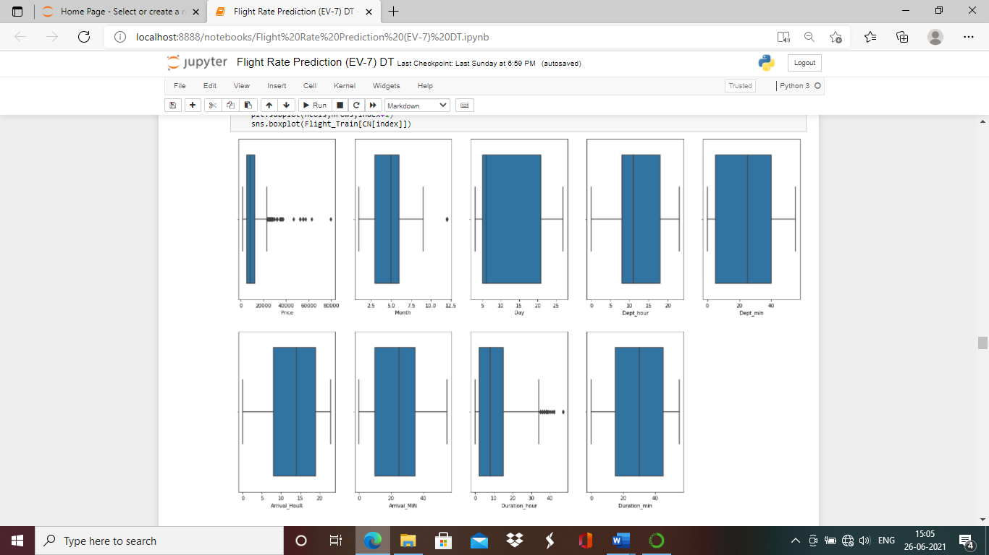

We will treat the outlier from Price and Duration_hour columns with soft capping method.

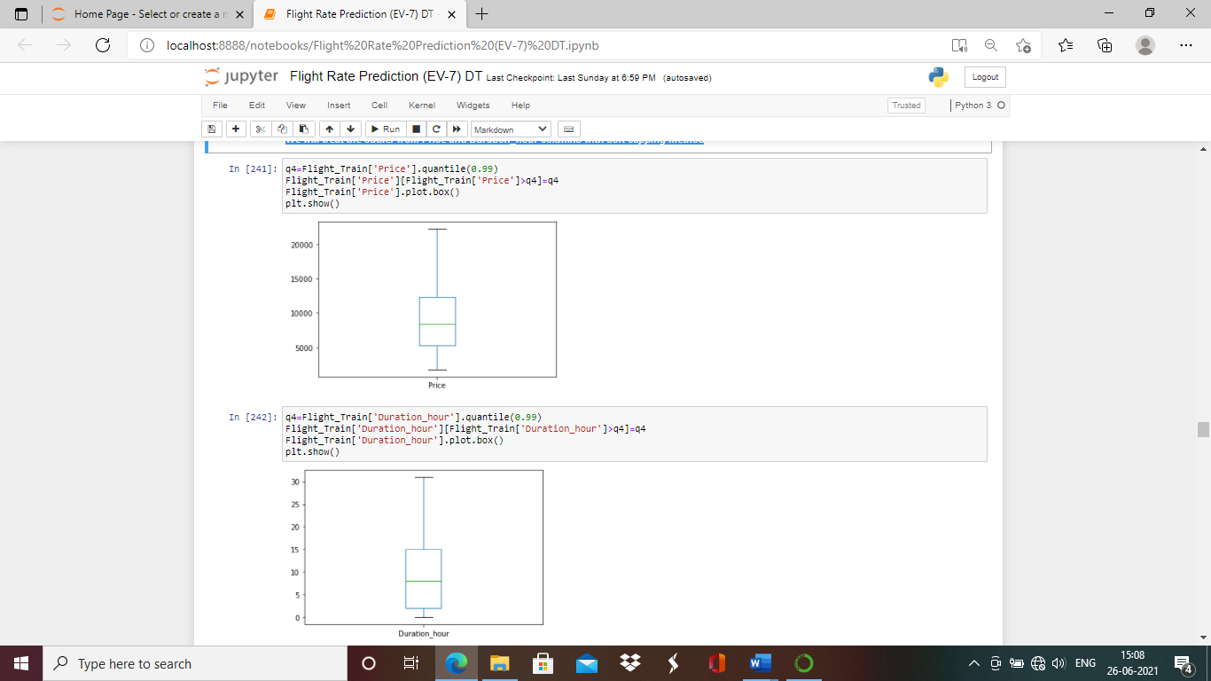

Outlier from both the columns are removed.

**Encoding**

All object data type of columns to be converted from alphabetical variable to numerical numbers.

We will perform that with encoding method.

We will apply One hot encoder on Airline,Source,Destination,Total_Stops,Additional_Info columns.

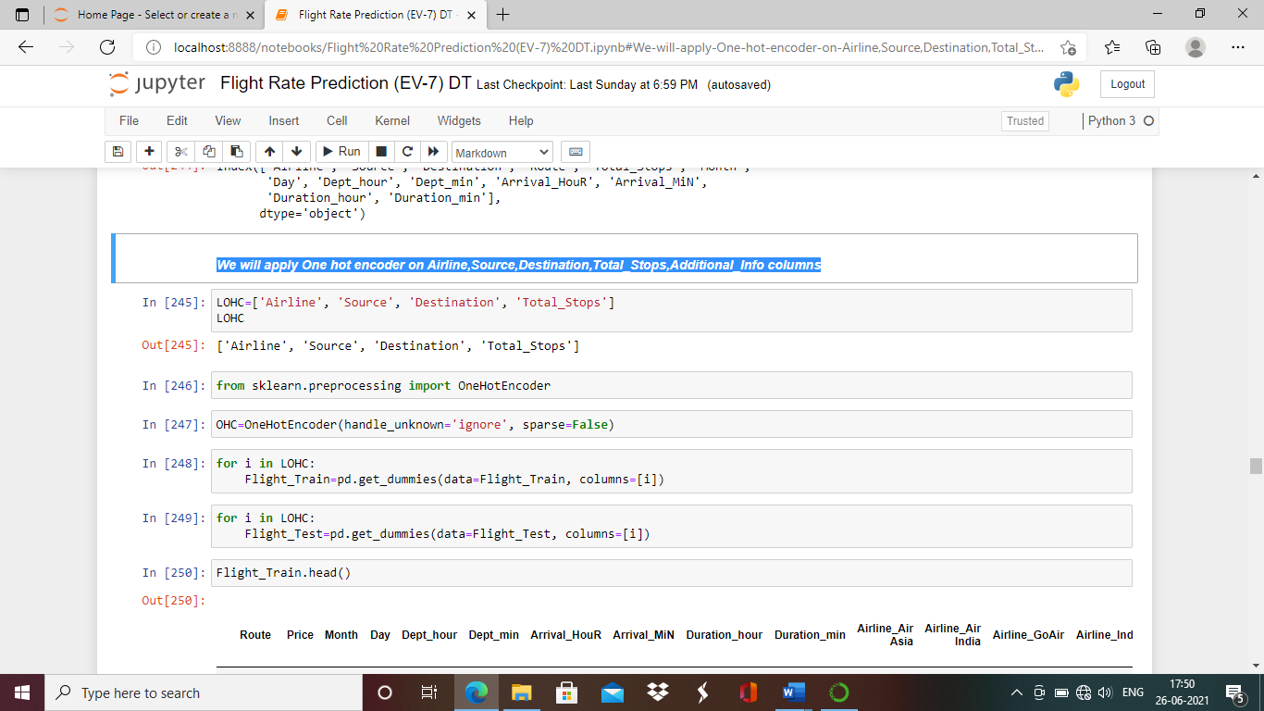

We will drop the Route column as we have got total stops of flight.

Take off place and Destination place makes us understand from where passenger is going to take off and where passenger is going to land. The route o cities in the journey where flight is going doesn't matter.

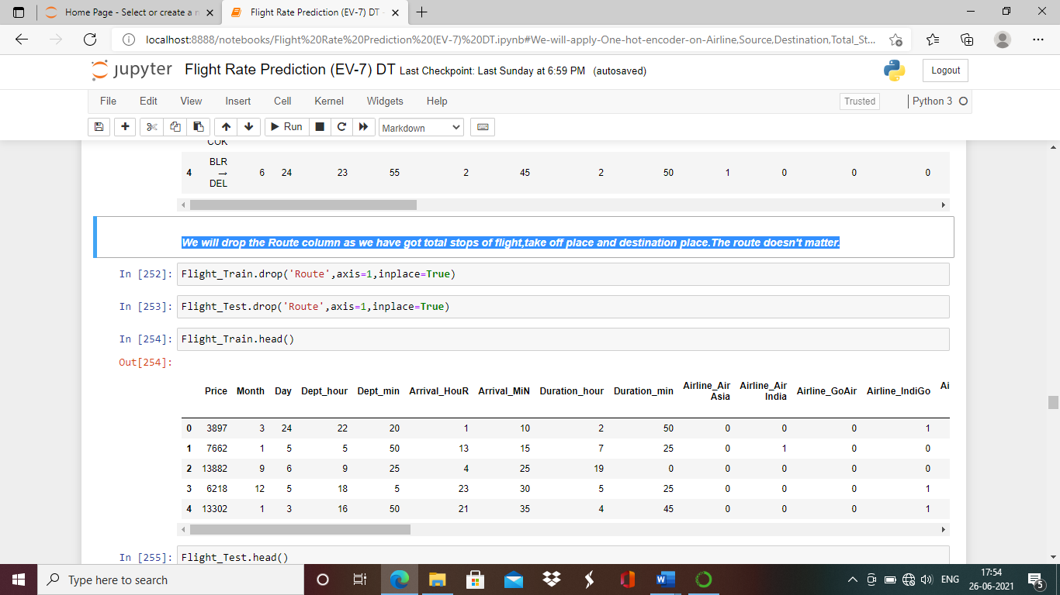

**Data Splitting.**

We will split the data in X and Y.

X set contains all the independent columns and Y set is dependent column.

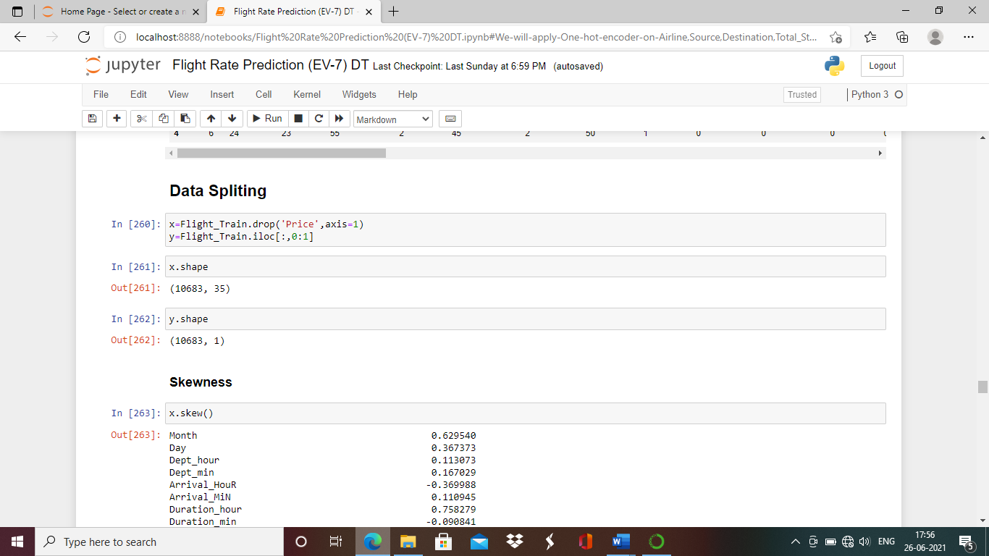

**Skewness**

Skewness measures the deviation of a random variable’s given distribution from the normal distribution, which is symmetrical on both sides. Models don’t perform better when data is skewed and the reason behind this is that the tapering ends or the tail region of the skewed data distributions are basically the outliers in the data and it is known to us that outliers can severely damage the performance of a statistical model the best example of this being regression-models which show very bad results when trained over skewed data. Hence, before running X set the we should check the skewness of each numerical column and not categorized column.

Skew value of column should always be between -0.5 to 0.5.

We will check the skewness of each column now.

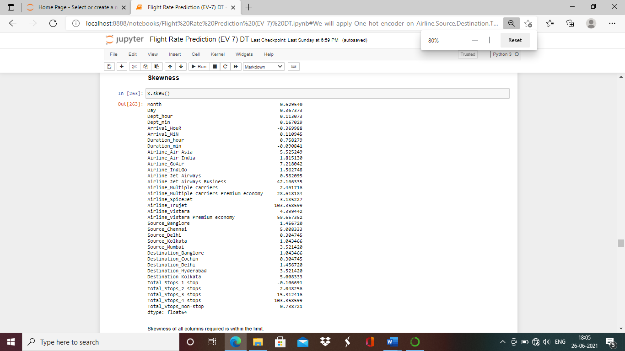

Skewness of all columns required is within the limit.

**Scaling**

Scaling is the final treatment we need to do before executing the data in model for prediciotn.

Scaling is performed when there is vast difference in range of data within column.There are various methods we can perform feature scaling. (i.e Minmax scaler ,standard scaler,Robust scaler etc.

We are using Min max scaler for data set as standard deviation is small.

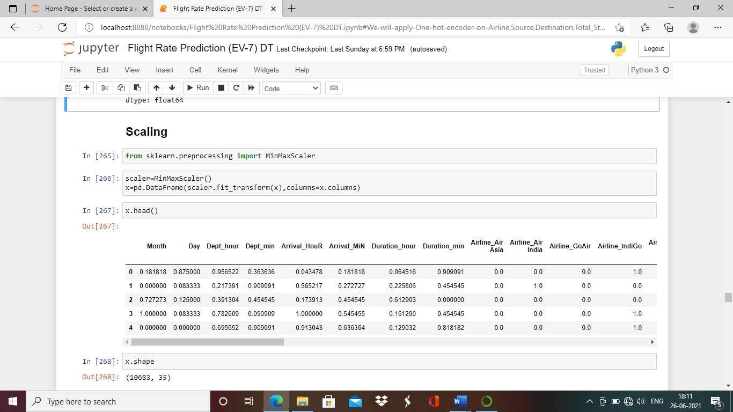

Data is ready for model execution after treating the missing values, encoding, removing skewness and scaling.

**Building Machine Learning Models**

For model execution we have to split the data in train and test data which plays a very critical role in model performance, as imbalanced fitting of test and train data can impact model performance. We should always try keeping training data close to 70% for better performance.

This being a regression problem we can use various models like linear regression, Random Forest regressor, XgBoost regressor, regularization like (Lasso, Ridge and Elastic) etc.

I have tried running all the above-mentioned model and also have also applied hyper parameter tunning to improve the performance of each model. After running all models I have to come to conclusion at random forest regressor model is best performing model ,we will check the performance and details further.

Initially we will check the best random state for model performance using logistic regression.

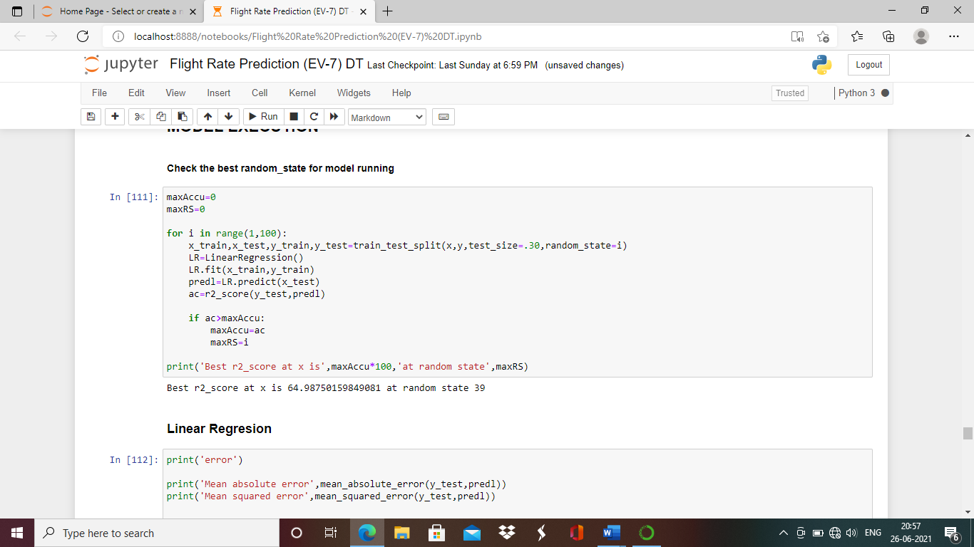

The best r2_Score is 64.98 at random state 39.

Linaer Regression

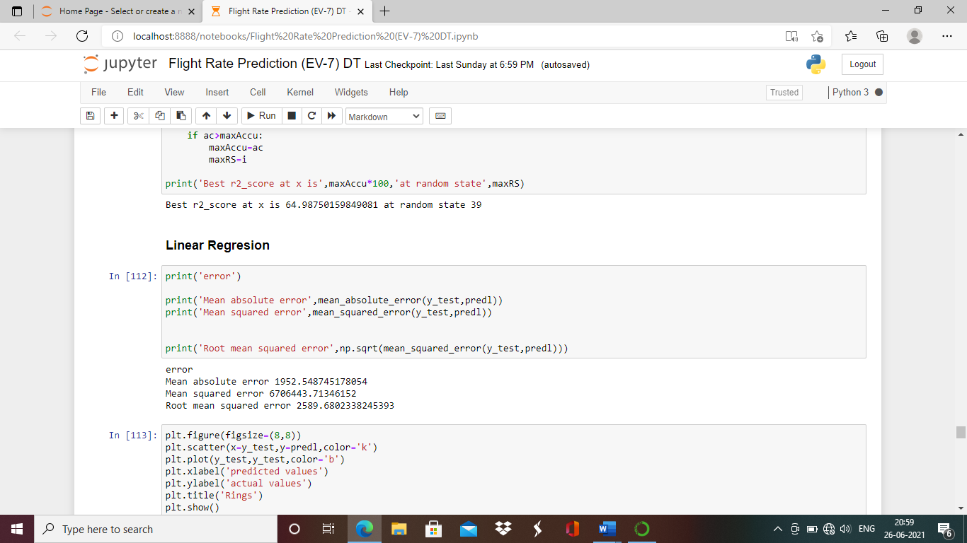

### Hyper Parameter Tunning for Linear Regression Model

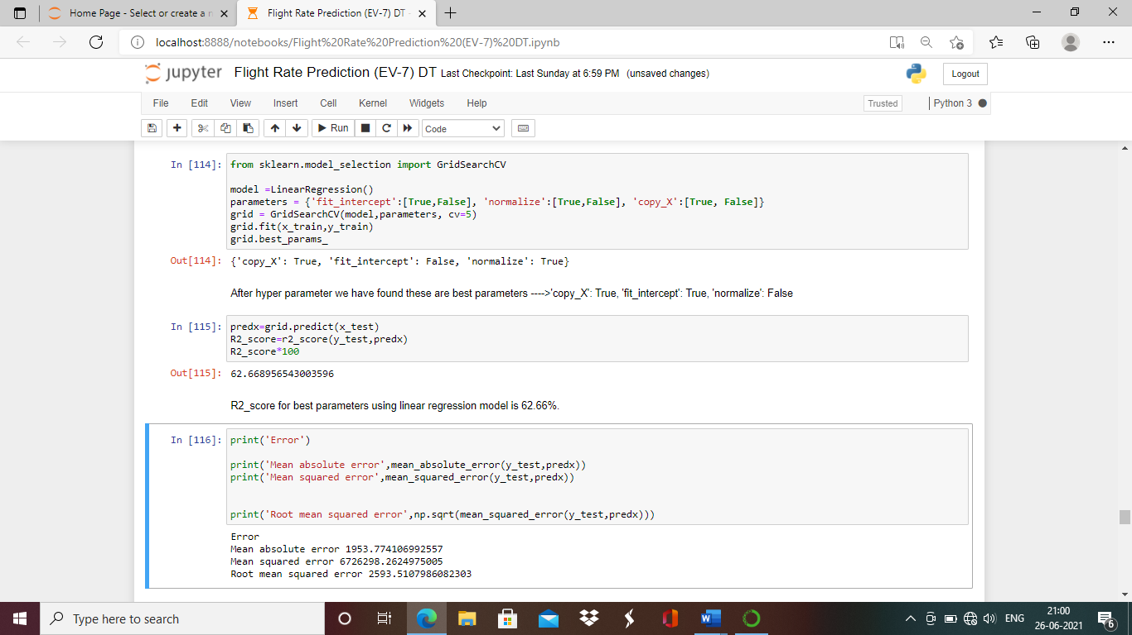

We will check scatter plot of predicted values v/s acctual values

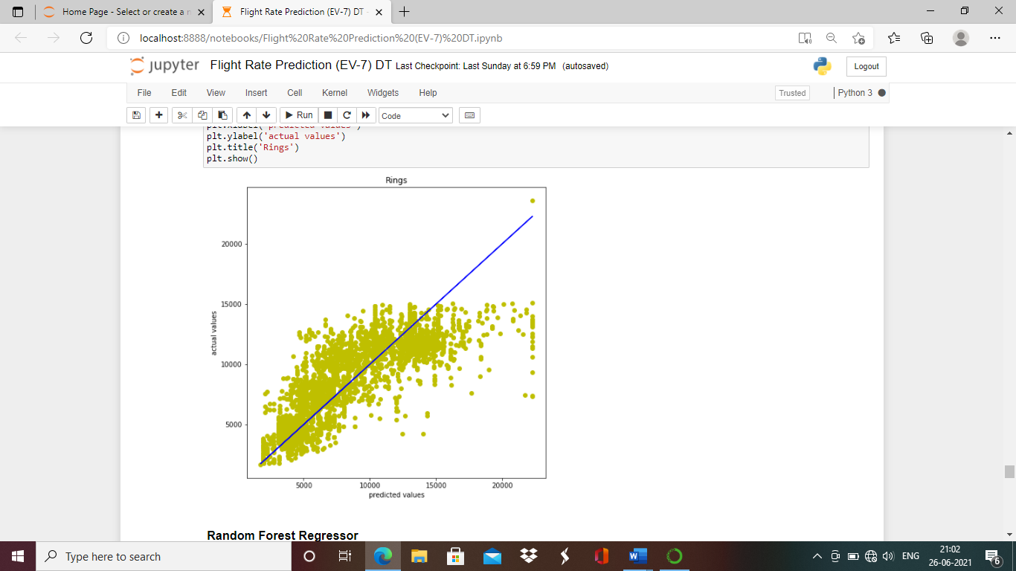

**Random Forest Regressor**

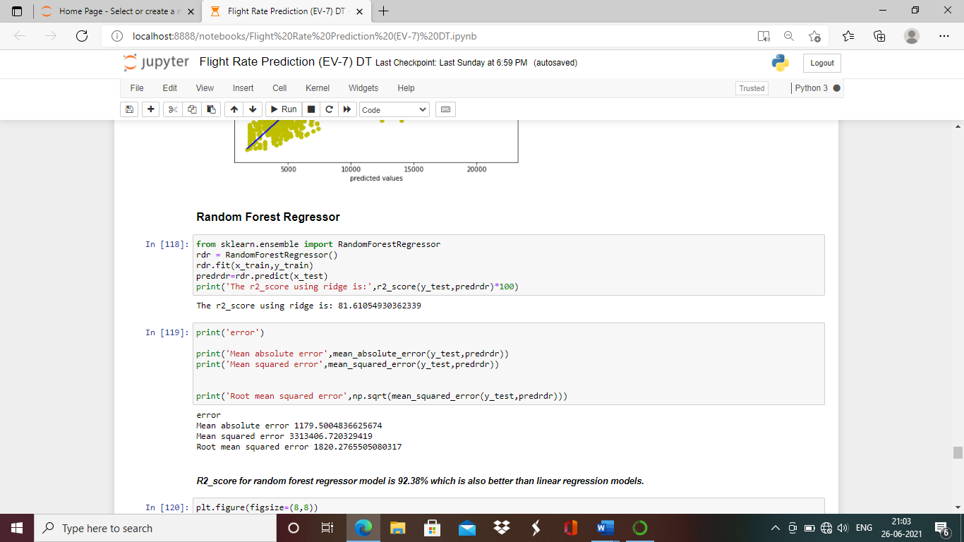

R2_score without hyper tunning is 81.61%.

Now let’s apply hyper parameter tunning

#### Hyperparameter Tunning for Random Forest Regressor

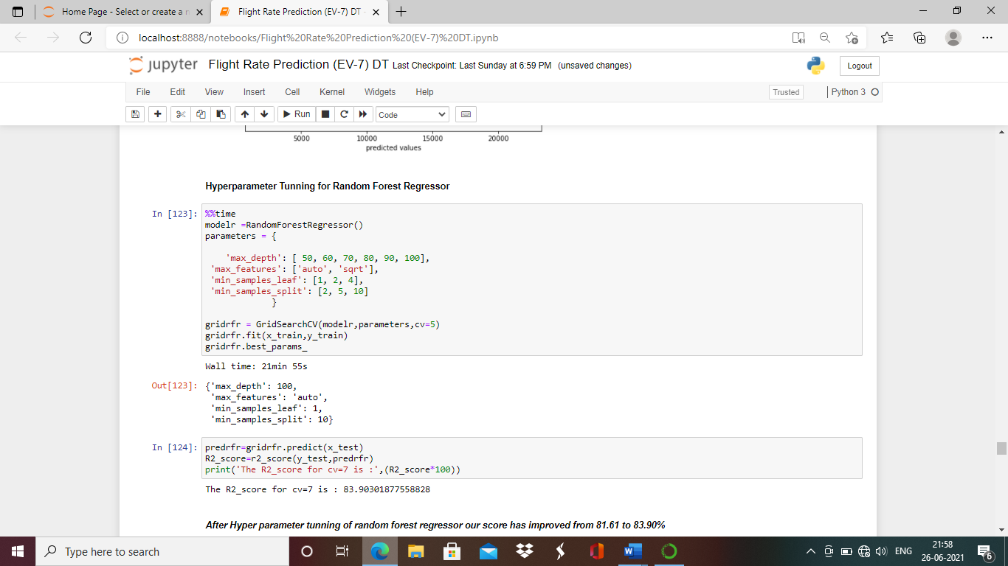

We will check scatter plot of predicted values v/s acctual values

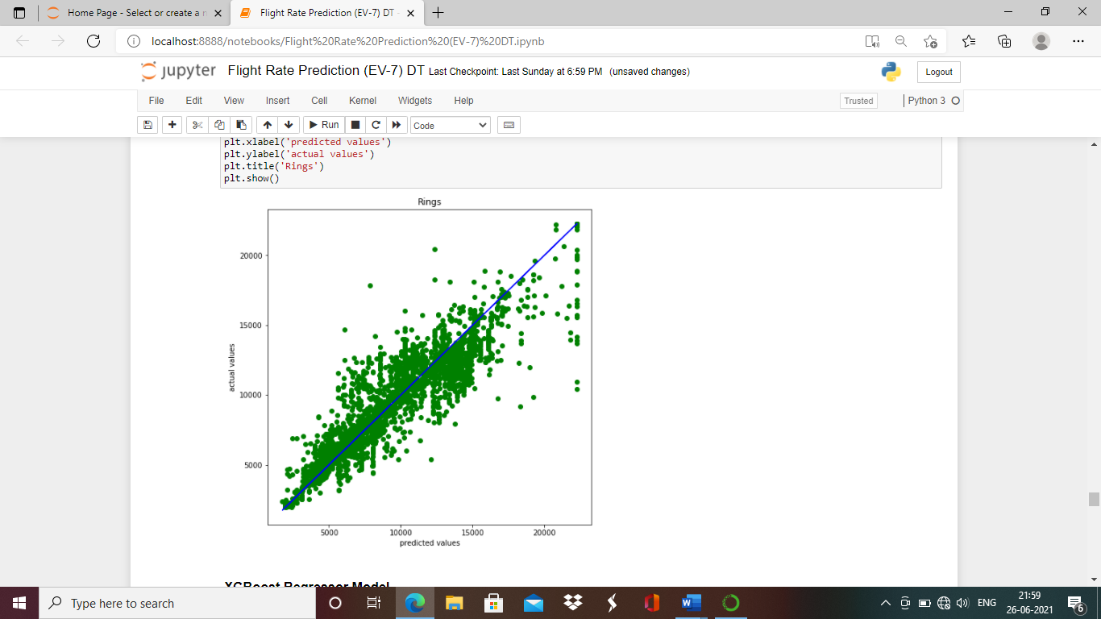

### **XgBoost Regressor Model**

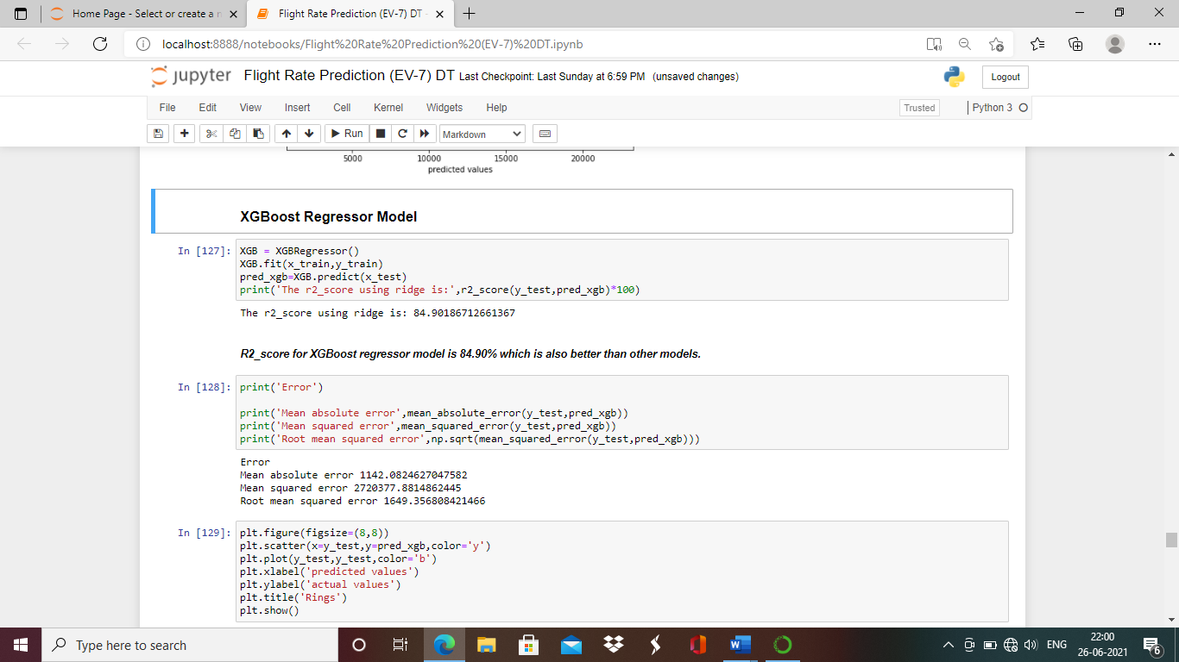

#### Hyperparameter Tunning for XgBoost Regressor

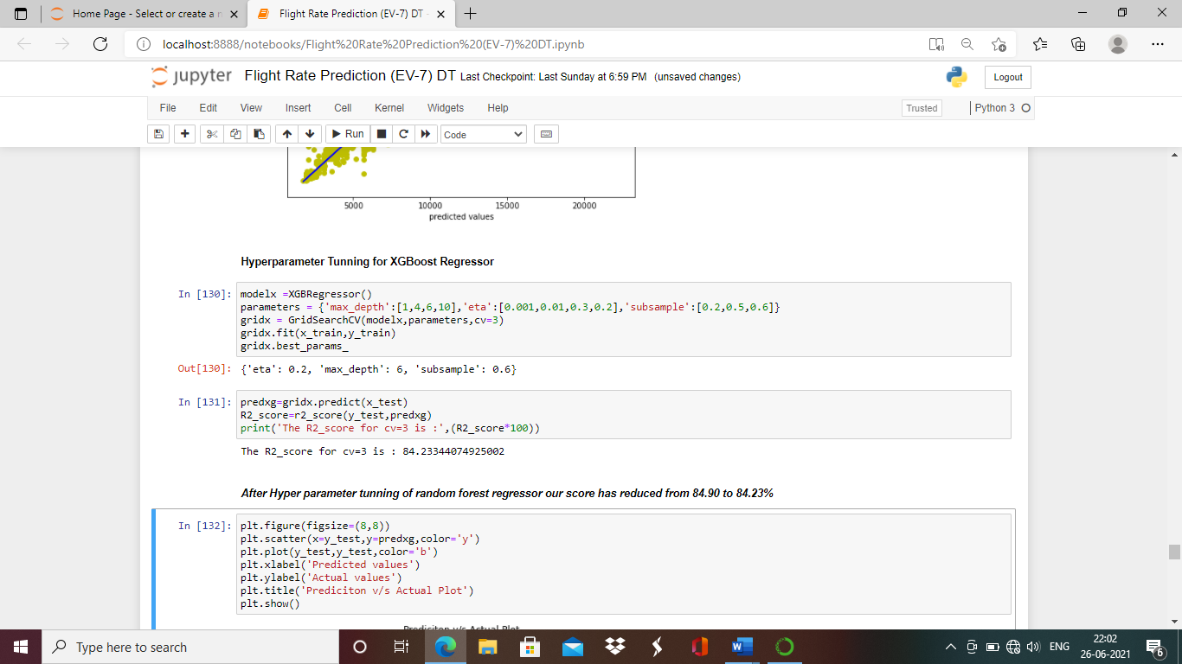

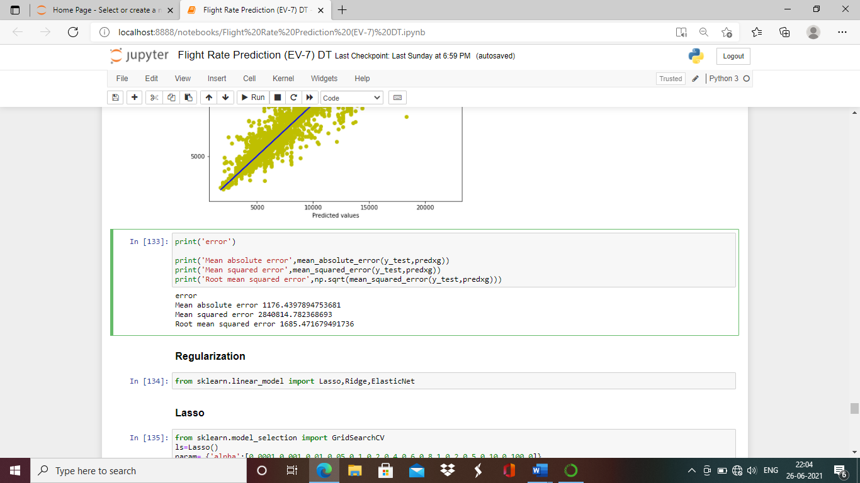

***After Hyper parameter tunning of XgBoost regressor our score has reduced from 84.90 to 84.23%***

We will check scatter plot of predicted values v/s acctual values

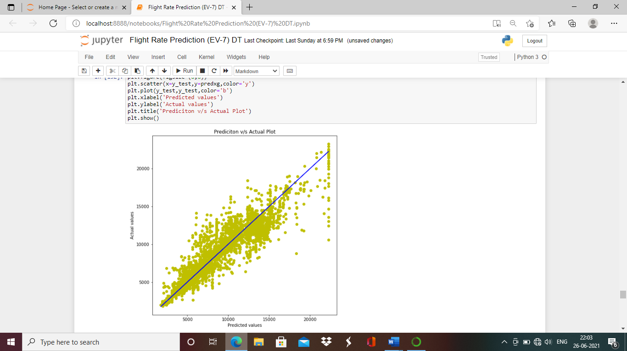

#### After running the different models and applying hyper tunning we can understand that XgBoost Regressor model is the best model supporting our dataset, with R2_score of 84.23% which is best from all the models.

Even we get the least root mean squared error and mean squared error for this model

(MAE: 1176.43 and RMSE: 1685.4)

**Concluding Remarks**

In Flight fare prediction dataset, we have introduced the whole pipeline of an end-to-end machine learning. We have described the dataset, and explored all the variables in the dataset. Checked if there are any missing values. Exploratory data analysis is performed using univariate, bivariate and multivariate columns for better understanding of data.

In this dataset problem featuring play’s critical role. We had to handle many categorical columns. Data featuring is performed by treating the missing the values, checking correlation between columns, encoding all the alphabetical columns to numerical. Outliers are cleared in dataset with quantile method and made ready to run the model. We have run various models to find the best model and found flight fare prediction has used XgBoost regressor model as best model .MAE and RMSE are very important values to be checked for verifying the performance of model in this dataset and we have found Low MAE and RMSE for XgBoost model.

Thank You!!!